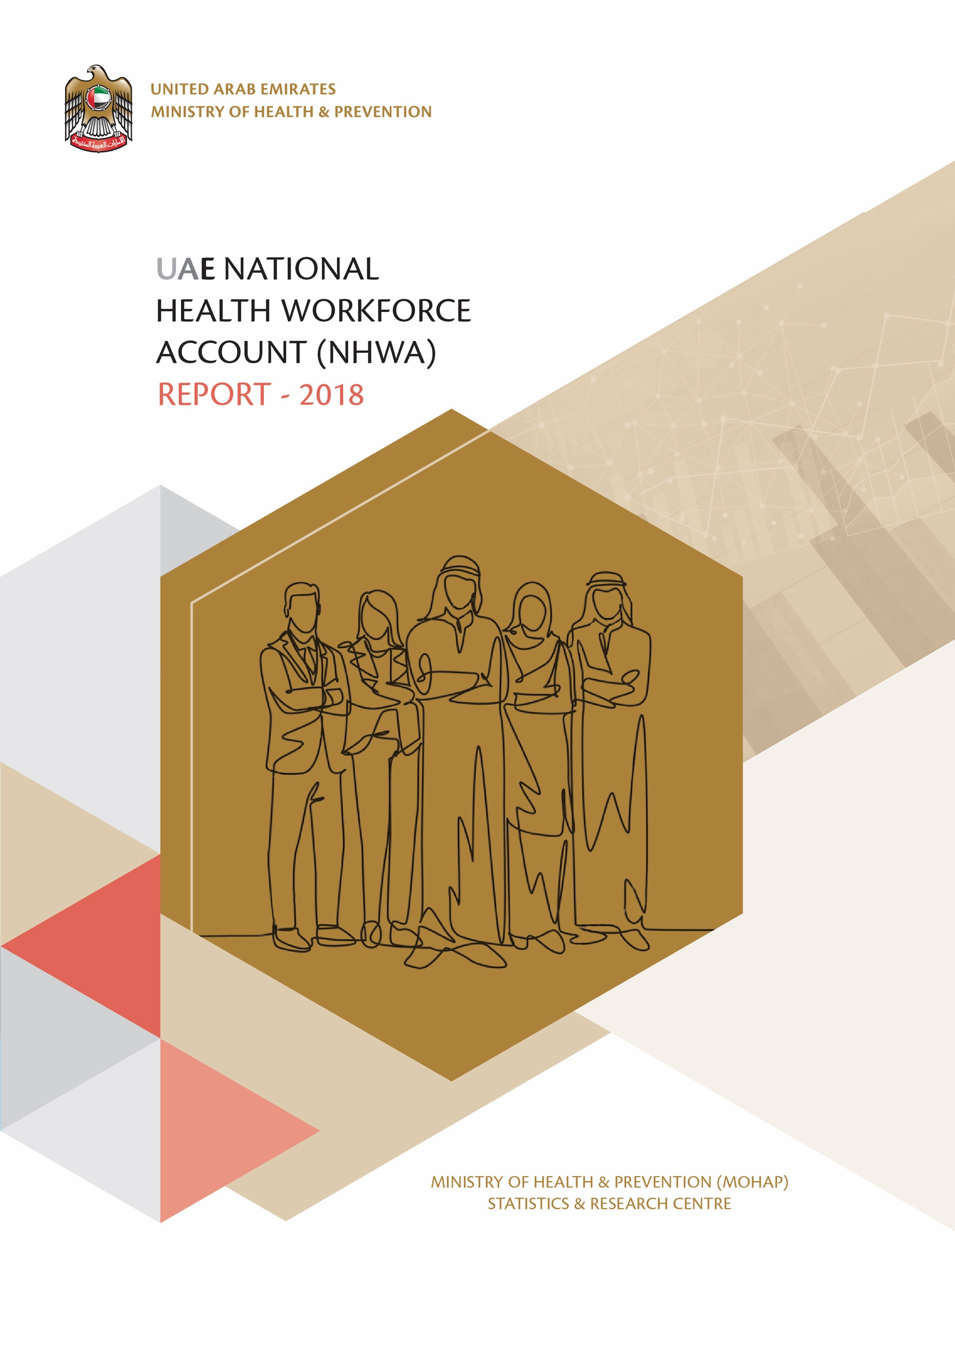



CONTRIBUTORS

- Ministry of Health & Prevention
- Ministry of Education
- Ministry of Education – Higher Education
- Ministry of Presidential Affairs
- Commission for Academic Accreditation
- Dubai Health Authority
- Dubai Healthcare City
- Department of Health - Abu Dhabi
- Federal Authority for Government Human Resources
- World Health Organization

KEY INDIVIDUALS

AUTHORS

Varunendra Swarup Verma
Business Analyst
Statistics and Research Centre
Ministry of Health & Prevention

Rahul Patil
Business Analyst
Statistics and Research Centre
Ministry of Health & Prevention

REVIEWERS

Dr. Alya Zaid Mohammed Harbi
Director
Statistics & Research Centre
Ministry of Health & Prevention

Adnan Yaqoot Ali Suwaid AlReyami
Director
Human Resources Department
Ministry of Health & Prevention

Dr. Sumaya Mohamed Abbas
Director
Nursing Department – Hospitals Sector
Ministry of Health & Prevention
Abeer Adel Mohamed Abdul Ghani
Acting Director
Organizing, Licensing & Advertising Department
Ministry of Health & Prevention

Dr. Lubna Ali AlShaali
Director
Public Health Policies Department
Ministry of Health & Prevention

Saqr AlHemeiri
Director
Training & Development Centre
Ministry of Health & Prevention

Dr. Shaikha Abdulkareem Abdool
Head of Data Science and Informatics Section
Statistics and Research Centre
Ministry of Health & Prevention

Hend Ali Ibrahim Al Mulla
Head of Statistics Section
Statistics and Research Centre
Ministry of Health & Prevention

ACKNOWLEDGEMENT
We would like to express our sincere thanks and appreciation to all departments of the Ministry of Health and Prevention, esteemed Ministries and other Governmental and Private authorities, who contributed generously towards the collection and confirmation of the data in this report. Without their support and experience, this report would not have been possible.

FOREWORD
The Statistics and Research Centre (SARC) of MOHAP have prepared the report for the World Health Organization (WHO) devised National Health Workforce Account (NHWA) programme for UAE for the calendar year 2018. Technical details of this entire programme can be viewed at https://www.who.int/hrh/documents/brief_nhwa_handbook/en/
This report contains information about the below areas of NHWA:
- Definition, characteristics and purpose behind implementation of this programme for UAE.
- Indicator values affecting health labour market cutting across education, labour workforce and population needs.
- Module wise detailed description and values of each indicator.
- Key comparisons of NHWA indicator values between UAE and other countries.
- MOHAP recommendations for addressing areas of concern with health workforce.
- Challenges faced by us during implementation.
The rationale behind presenting this report is for obtaining a holistic view of the UAE health workforce situation in terms of workforce statistics, skill and specialization adequacy, key policy regulations and information systems. We present the distinguishing aspects of UAE health workforce along with challenges and improvement areas, when addressed will catapult UAE’s health workforce to the greatest heights of population satisfaction and worker efficacy.
One of the limitations of this report is that we could not publish results for all of the NHWA indicators because those data items were not available with the identified stakeholders. This has been highlighted in the chapter 12 relating to Challenges with NHWA implementation. We are highly optimistic that these pending areas shall be addressed in the subsequent NHWA UAE Report for 2019.

ABBREVIATIONS & ACRONYMS

Abbreviation | Full Form
CPD | Continuing Professional Development
DHA | Dubai Health Authority
DHCC | Dubai Health Care City
DOH | Department of Health – Abu Dhabi
FAHR | Federal Authority for Government Human Resources
FCSA | Federal Competitiveness and Statistics Authority
HIS | Health Information System
HRHIS | Human Resource for Health Information System
HWF | Health Workforce
IHR | International Health Regulation
IPE | Inter-professional Education
MOE | Ministry of Education
MOE – HE | Ministry of Education – Higher Education
MOHAP | Ministry of Health & Prevention
MOHRE | Ministry of Human Resources & Emiratisation
SDG | Sustainable Development Growth
UHC | Universal Health Coverage
WHO | World Health Organization

TABLE OF CONTENTS
1. CONTRIBUTORS 1
2. KEY INDIVIDUALS 2
2.1 AUTHORS 2
2.2 REVIEWERS 2
3. ACKNOWLEDGEMENT 3
4. FOREWORD 4
5. ABBREVIATIONS & ACRONYMS 5
6. TABLE OF CONTENTS 6
7. LIST OF FIGURES 9
8. LIST OF TABLES 10
9. CHAPTER 1: INTRODUCTION TO NATIONAL HEALTH WORKFORCE ACCOUNT 11
9.1 Definition 11
9.2 Characteristics 11
9.3 Purpose 11
9.4 Benefits 12
10. CHAPTER 2: NHWA MODULES 13
11. CHAPTER 3: NHWA UAE 2018 INDICATORS VALUES 14
12. CHAPTER 4: MODULE 1 – ACTIVE HEALTH WORK STOCK 18
12.1 Key Areas 18
12.2 Indicator Data 18
12.3 Module Summary 34
13. CHAPTER 5: MODULE 2 – EDUCATION & TRAINING 35
13.1 Key Areas 35
13.2 Indicator Data 36
13.3 Module Summary 36
14. CHAPTER 6: MODULE 3 - EDUCATION & TRAINING REGULATION AND ACCREDITATION 37
14.1 Key Areas 37
14.2 Indicator Data 38
14.3 Module Summary 47
15. CHAPTER 7: MODULE 4 – EDUCATION FINANCES 48
15.1 Key Areas 48
16. CHAPTER 8: MODULE 5 – HEALTH LABOUR MARKET FLOWS 49
16.1 Key Areas 49
17. CHAPTER 9: MODULE 6 – EMPLOYMENT CHARACTERISTICS AND WORKING CONDITIONS 50
17.1 Key Areas 50
17.2 Indicator Data 51
17.3 Module Summary 54
18. CHAPTER 10: MODULE 7 - HEALTH WORKFORCE SPENDING & REMUNERATION 55
18.1 Key Areas 55
18.2 Indicator Data 56
18.3 Module Summary 57
19. CHAPTER 11: MODULE 8 - SKILL-MIX COMPOSITION FOR MODELS OF CARE 58
19.1 Key Areas 58
19.2 Indicator Data 59
19.3 Module Summary 67
20. CHAPTER 12: MODULE 9 - GOVERNANCE AND HEALTH WORKFORCE POLICIES 68
20.1 Key Areas 68
20.2 Indicator Data 69
20.3 Module Summary 73
21. CHAPTER 13: MODULE 10 – HEALTH WORKFORCE INFORMATION SYSTEMS 73
21.1 Key Areas 74
21.2 Indicator Data 75
21.3 Module Summary 80
22. CHAPTER 14: NHWA INTERNATIONAL COMPARISONS 81
22.1 Overview 81
22.2 Gender Distribution Indicator 81
22.2.1 Medical Doctor 81
22.2.2 Nursing 82
22.3 Category-wise Health Worker Density indicator 82
22.3.1 Medical Doctor per 10 000 population 82
22.3.2 Nurses and Midwifery per 10 000 population 83
22.3.3 Dentists per 10 000 population 83
22.3.4 Pharmacists per 10 000 population 84
22.4 Key Summary for UAE 84
23. CHAPTER 15: MOHAP RECOMMENDATIONS 85
23.1 Capability Indicator Status 85
23.2 MOHAP Recommendations 86
23.2.1 Recommendation for Accreditation of non-compulsory education and training institutions 86
23.2.2 Recommendation for measurement of Impact of health training on health system and population 87
23.2.3 Recommendation for implementation of accreditation standards for IPE 88
23.2.4 Recommendation for integration of CPD into National Education Plan 89
23.2.5 Recommendation for capacity of Field Epidemiology Training Programmes 90
23.2.6 Recommendation for accreditation of in-service training programmes for advancing roles of Nurses 91
23.2.7 Recommendation for reporting capabilities of HRHIS for IHR 93
23.2.8 Recommendation for reporting capabilities of HRHIS for Skilled attendance at birth 94
23.2.9 Recommendation for HRHIS production of geocoded health facility locations 95
23.2.10 Recommendation for HRHIS in reporting on outputs from education and training institutions 96
24. CHAPTER 16: CHALLENGES 97
24.1 General Challenges 97
24.2 Challenges in NHWA Data Collection 98
24.2.1 Module 1 – Active Health Work Stock 98
24.2.2 Module 2 – Education & Training 100
24.2.3 Module 4 – Education Finances 102
24.2.4 Module 5 – Health Labour Market Flows 103
24.2.5 Module 6 – Employment Characteristics and Working Conditions 104
24.2.6 Module 7 – Health Workforce Expenditure 105
24.2.7 Module 10 – Health Workforce Information Systems 107
25. Glossary 108

LIST OF FIGURES

Figure 1 - NHWA Purpose 11
Figure 2 - NHWA Benefits 12
Figure 3 - NHWA Modules 13
Figure 4 - Module 1 Key Areas 18
Figure 5 - Category-wise Manpower UAE chart 20
Figure 6 - Category-wise Manpower Abu Dhabi chart 22
Figure 7 - Category-wise Manpower Dubai chart 23
Figure 8 - Category-wise Manpower Sharjah chart 24
Figure 9 - Category-wise Manpower Ajman chart 25
Figure 10 - Category-wise Manpower Umm Al Quwain chart 26
Figure 11 - Category-wise Manpower Ras Al Khaimah chart 27
Figure 12 - Category-wise Manpower Fujairah chart 28
Figure 13 - Gender-wise Manpower chart 31
Figure 14 - Sector-wise Manpower chart 33
Figure 15 - Module 2 Key Areas 35
Figure 16 - Module 3 Key Areas 37
Figure 17 - Module 4 Key Areas 48
Figure 18 - Module 5 Key Areas 49
Figure 19 - Module 6 Key Areas 50
Figure 20 - Module 7 Key Areas 55
Figure 21 - Module 8 Key Area 58
Figure 22 - Module 9 Key Areas 68
Figure 23 - Module 10 Key Areas 74
Figure 24 - Medical Doctor - Global Gender Comparison 81
Figure 25 - Nurses - Global Gender Comparison 82
Figure 26 - Global Medical Doctor densities 82
Figure 27 - Global Nurse and Midwife Density 83
Figure 28 - Global Dentists Density 83
Figure 29 - Global Pharmacist Density 84
Figure 30 - Implementation Areas for measurement of education and training on health systems and population served 87
Figure 31 - Steps for accreditation of IPE 88
Figure 32 – CPD Inclusion process in National Education Plan 89
Figure 33 - IHR Framework 93

LIST OF TABLES
Table 1 - NHWA UAE 2018 Core Indicator values 17
Table 2 - Category-wise Manpower Summary 20
Table 3 - Category-wise Abu Dhabi Summary 22
Table 4 - Category-wise Dubai Summary 23
Table 5 - Category-wise Sharjah Summary 24
Table 6 - Category-wise Ajman Summary 25
Table 7 - Category-wise Umm Al Quwain Summary 26
Table 8 - Category-wise Ras Al Khaimah Summary 27
Table 9 - Category-wise Fujairah Summary 28
Table 10 - Gender-wise Manpower Summary 31
Table 11 - Sector-wise Manpower Summary 33
Table 12 - Capability Indicator Status 85

CHAPTER 1: INTRODUCTION TO NATIONAL HEALTH WORKFORCE ACCOUNT

Definition
The National Health Workforce Account (NHWA) is a system developed under the direction of the World Health Organization (WHO) Health Workforce Department using which countries can collect evidence-based data pertaining to the health workforce, which is progressively monitored using a set of indicators. The health workforce data collected encompasses areas such as health workforce stock and distribution, education and training - capacity, regulations and finances, employment characteristics and working conditions, workforce expenditure and remuneration, skill-mix distribution, governance & policies and human resource information systems.

Characteristics
The NHWA is a data-intensive programme which has the below mentioned characteristics:
- Provides a harmonized and integrated method for health workforce data collection.
- Technically defines a set of indicators for precise data acquisition and analysis.
- Promotes a multi-stakeholder synergistic environment for holistic data generation.
- Improves the interoperability of health information systems spread across multiple public and private entities.
- Creates an official platform for secure dissemination of health workforce indicator data.

Purpose
The primary purpose of the NHWA programme is to facilitate the standardization and interoperability of health workforce data and track performance towards Universal Health Coverage (UHC).
The health workforce indicator data is collected, reconciled, analyzed, verified and reported in order to meet below objectives:

Figure 1 - NHWA Purpose
The implementation of NHWA programme shall serve following purposes for UAE:
- Achieve the Universal Health Coverage and Sustainable Development Goals milestones.
- First country to report on all NHWA modules.
- Provide best in class services and attain top global leadership in healthcare.
- Achieve holistic development of healthcare education and systems.
- Better planning for dealing with increasing healthcare demand.

Benefits

The implementation of NHWA provides benefits global, national and regional levels.

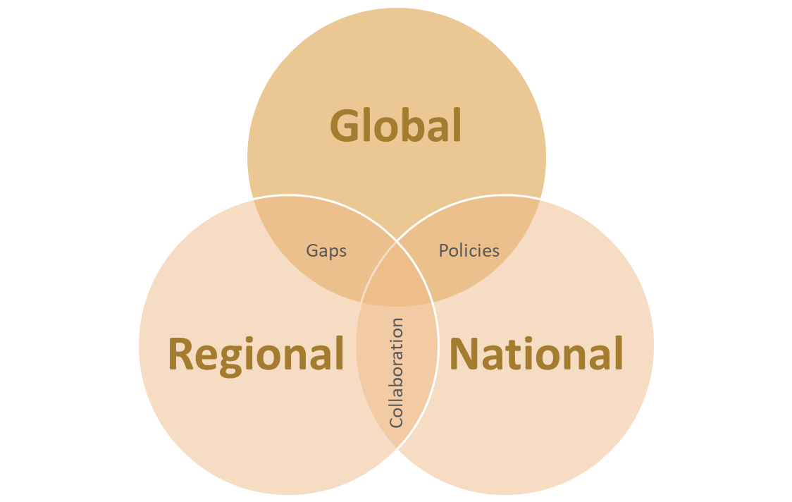
Figure 2 - NHWA Benefits

At Global level, NHWA implementation results in below benefits:
- Formulation of evidence-based health workforce plans and policies.
- Data Standardization and interoperability.
- Establishment of a benchmark for health workforce data standards.
- Facilitation of standardized data comparisons against other countries.

At National Level, NHWA implementation results in below benefits:
- Review of National health workforce data.
- Identification of gaps, shortages and mismatches in health workforce data.
- Assessment of existing policies and plans that impact the health workforce.
- Strengthened multi-stakeholder collaboration resulting in creation of inter-sectoral policies, strategies and plans.

At Regional Level, NHWA Implementation results in below benefits:
- Accurate capture of region level health workforce data.
- Facilitation of cross-country capacity building, information and data exchange.
- Aid in sophisticated research about future trends of health workforces regionally.

CHAPTER 2: NHWA MODULES

The NHWA contains a set of 78 core indicators, spread over 10 modules that aim to support national-level HWF policies to progress towards UHC and SDGs. The indicators in the 10 modules feed into three crucial labour market components: the education component, the labour force component and the component serving population health needs.
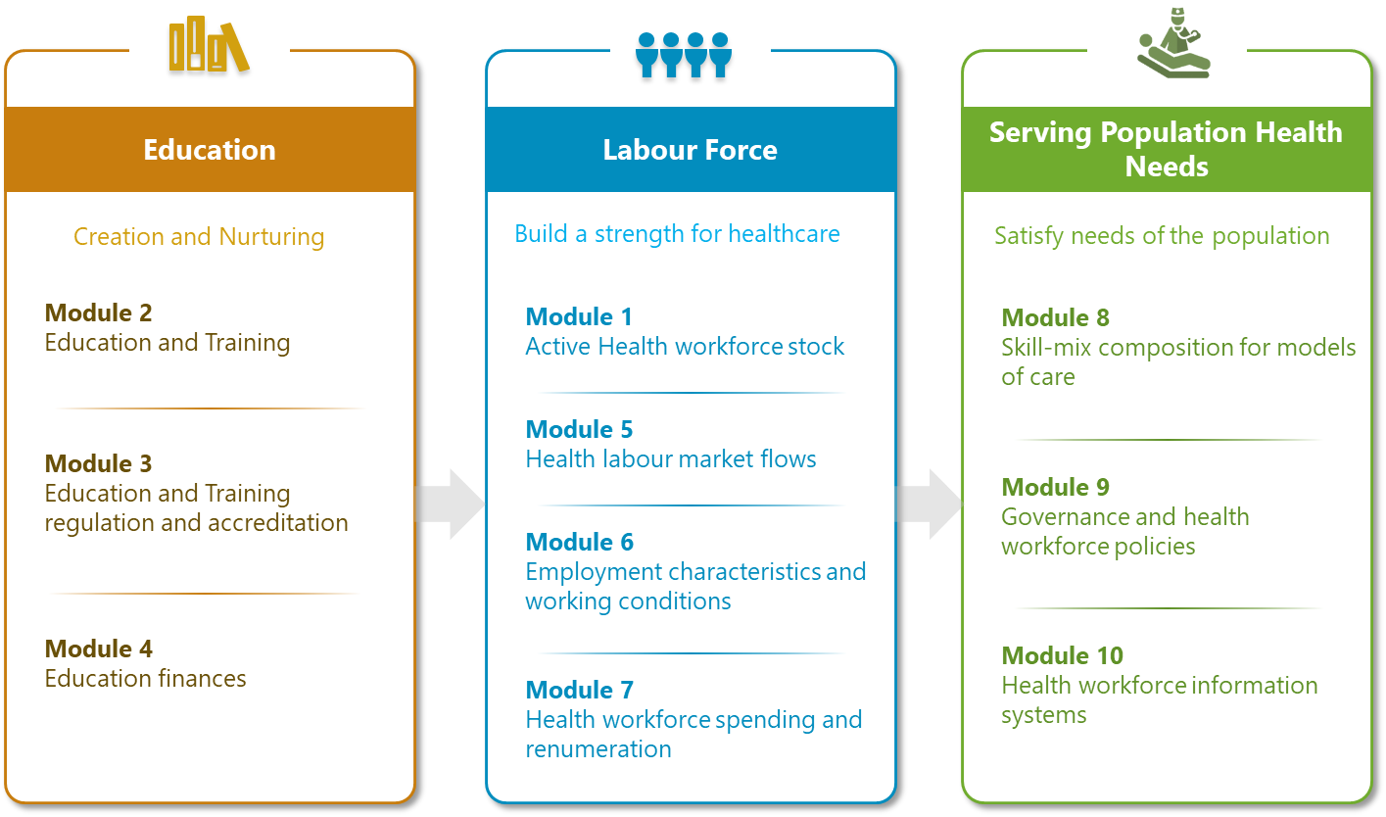
Figure 3 - NHWA Modules

CHAPTER 3: NHWA UAE 2018 INDICATORS VALUES

Indicator Id | Unique Reference Id | Indicator Title | Value | Unit | Data Source
1.01 | ID_169 | Health worker density  (UAE) | 126 | per 10 000 population | MOHAP  DOH  DHA  DHCC  MOPA
1.02 | ID_170 | Health worker density at subnational level | Abu Dhabi : 189  Umm Al Quwain : 156  Sharjah : 120  Ajman : 116  Fujairah : 106  Dubai : 92  Ras Al Khaimah : 90 | per 10 000 population | Same as above
1.03 | ID_171 | Health worker distribution by age group  (UAE – Public Sector Partial) | <25 : 0.29  25–34 : 40.75  35–44 : 33.43  45–54 : 17.05  55–64 : 6.70  >= 65 : 1.79 | Percent (%) | MOHAP  MOPA  DOH
1.04 | ID_172 | Female health workforce  (UAE) | 64.28 | Percent (%) | MOHAP  DOH  DHA  DHCC  MOPA
1.05 | ID_173 | Health worker distribution by facility ownership  (UAE) | Public : 34.59  Private : 65.41 | Percent (%) | Same as above
1.06 | ID_174 | Health worker distribution by facility type  (UAE – Public Sector Partial) | Hospitals: 47.45  Ambulatory Facilities: 30.99  Retail Facilities: 9.34  Others: 5.56  Government Agencies: 3.35  Ancillary Facilities: 1.90  Residential Care Facilities : 1.41 | Percent (%) | MOHAP  MOPA  DOH
2.01 | ID_178 | Master list of accredited health workforce education and training institutions  (UAE) | Yes | NA | MOE
3.01 | ID_185 | Standards for the duration and content of education and training  (UAE) | Yes | NA | CAA
3.02 | ID_186 | Accreditation mechanisms for education and training institutions and their programmes  (UAE) | Partly | NA | CAA
3.03 | ID_187 | Standards for social accountability  (UAE) | Yes | NA | CAA
3.04 | ID_188 | Standards for social accountability effectively implemented  (UAE) | Partly | NA | CAA  MOHAP
3.05 | ID_189 | Existence of national and/or subnational standards for the social determinants of health in accreditation mechanisms  (UAE) | Yes | NA | CAA  MOHAP
3.06 | ID_190 | Standards for interprofessional education  (UAE) | Partly | NA | CAA
3.07 | ID_191 | Agreement on accreditation standards  (UAE) | Yes | NA | CAA
3.08 | ID_192 | Continuing professional development  (UAE) | Partly | NA | CAA  MOHAP
3.09 | ID_193 | In-service training  (UAE) | Yes | NA | CAA
6.01 | ID_209 | Standard working hours  (UAE – Public Sector) | 48 | Hours per week | MOHAP
6.03 | ID_211 | Regulation on working hours and conditions  (UAE – Public Sector) | Yes | NA | FAHR
6.05 | ID_213 | Regulation on social protection  (UAE – Public Sector) | Yes | NA | FAHR
7.06 | ID_224 | Policies on public sector wage ceilings  (UAE – Public Sector) | Yes | NA | MOHAP
7.07 | ID_225 | Gender wage gap  (UAE – Public Sector Partial) | 0 | Percent (%) | MOHAP
8.01 | ID_226 | Percentage of health workforce working in hospitals  (UAE – Public Sector Partial) | 47.45 | Percent (%) | MOHAP  MOPA  DOH
8.02 | ID_227 | Percentage of health workforce working in residential long-term care facilities  (UAE – Public Sector Partial) | 1.41 | Percent (%) | Same as above
8.03 | ID_228 | Percentage of health workforce working in ambulatory health care  (UAE – Public Sector Partial) | 30.99 | Percent (%) | Same as above
8.04 | ID_229 | Specialist surgical workforce  (UAE) | 62.64 | Per 100 000 population | UAE Level
8.05 | ID_230 | Family medicine practitioners  (UAE) | 81.45 | Per 100 000 population | UAE Level
8.06 | ID_231 | Existence of advanced nursing roles  (UAE) | Partly | NA | MOHAP
8.07 | ID_232 | Availability of human resources to implement the International Health Regulations  (UAE – Public Sector) | Sustainable Capacity | NA | MOHAP
8.08 | ID_233 | Applied epidemiology training programme  (UAE – Public Sector) | Limited Capacity | NA | MOHAP
9.01 | ID_234 | Mechanisms to coordinate an intersectoral health workforce agenda  (UAE – Public Sector) | Yes | NA | MOHAP
9.02 | ID_235 | Central health workforce unit  (UAE – Public Sector) | Yes | NA | MOHAP
9.03 | ID_236 | Health workforce planning processes  (UAE – Public Sector) | Yes | NA | MOHAP
9.04 | ID_237 | Education plans aligned with national health plan  (UAE – Public Sector) | Yes | NA | MOHAP
9.05 | ID_238 | Institutional models for assessing  health care staffing needs  (UAE – Public Sector) | Yes | NA | MOHAP
10.01 | ID_239 | HRHIS for reporting on International Health Regulations  (UAE – Public Sector) | No | NA | MOHAP
10.03 | ID_241 | HRHIS for reporting on skill attendance at birth requirements  (UAE – Public Sector) | No | NA | MOHAP
10.04 | ID_242 | HRHIS for reporting on outputs from education and training institutions  (UAE – Public Sector) | No | NA | MOHAP
10.05 | ID_243 | HRHIS for tracking the number of entrants to the labour market  (UAE – Public Sector) | Yes | NA | MOHAP
10.06 | ID_244 | HRHIS for tracking the number of active stock on the labour market  (UAE – Public Sector) | Yes | NA | MOHAP
10.07 | ID_245 | HRHIS for tracking the number of exits from the labour market  (UAE – Public Sector) | Yes | NA | MOHAP
10.08 | ID_246 | HRHIS for producing the geocoded location of health facilities  (UAE – Public Sector) | No | NA | MOHAP
Table 1 - NHWA UAE 2018 Core Indicator values

CHAPTER 4: MODULE 1 – ACTIVE HEALTH WORK STOCK

Overview: This module provides a detailed overview of the below aspects of health workforce:
- Stock – The total health workforce within the country as well as within all regions of the country in comparison to total population. This data enables ascertaining adequacy of health workforce for delivering UHC-oriented services.
- Distribution – The bifurcation of health workforce across gender and various age groups. The distribution of health workforce based on employment in different types of facilities and facilities ownership. This data enables gap detection in certain occupational sectors and highlights mismatches in geographical or sectoral distribution.
- Migration – Focus on quantity of foreign-born and foreign-trained workers in a country thereby revealing amount of reliance on foreign health workforce. This data will assist countries in meeting the GSHRH target of halving dependency on foreign-trained health workers through implementation of WHO Global Code of Practise.
Kindly Note - We have not received data for few indicators of this module. Details are present in section: ‎24.2.1 Module 1 – Active Health Work Stock

Key Areas
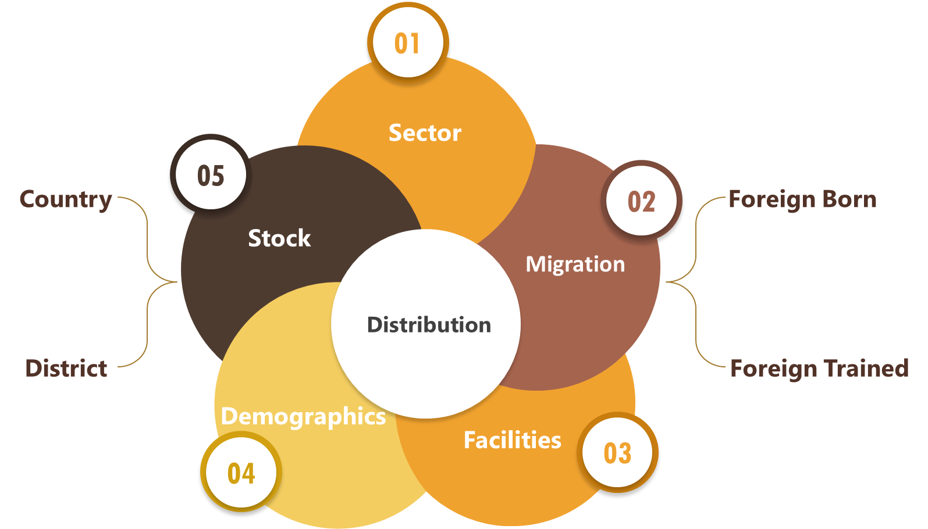
Figure 4 - Module 1 Key Areas

Indicator Data
Indicator Id | 1.01
Unique Reference Id | ID_169
Name | Health worker density
Definition | Number of health workers per 10 000 population inclusive of Medical Doctors, Dentists, Nurses, Pharmacists and Technicians.
Numerator | Number of health workers, defined in headcounts
Denominator | Total population
Value | 126
Unit | Per 10 000 population
Level | UAE
Data Sources | Ministry of Health and Prevention (MOHAP)  Department of Health (DOH)  Dubai Health Authority (DHA)  Dubai Healthcare City (DHCC)  Ministry of Presidential Affairs (MOPA)

Figure 5 - Category-wise Manpower UAE chart

Category | Value | Value per 10 000 population
Medical Doctors | 24345 | 26
Dentists | 6273 | 7
Pharmacists | 8469 | 9
Nurses | 55158 | 59
Technicians | 23876 | 25
Total | 118121 | 126
Table 2 - Category-wise Manpower Summary

Indicator Id | 1.02
Unique Reference Id | ID_170
Name | Density of active health workers per 10 000 population at subnational level
Definition | Number of active health workers at subnational administrative units.
Numerator | Number of health workers per region
Denominator | Total population per region
Value | - Abu Dhabi : 189  - Umm Al Quwain : 156  - Sharjah : 120  - Ajman : 116  - Fujairah : 106  - Dubai : 92  - Ras Al Khaimah : 90
Unit | Per 10 000 population
Data Sources | Ministry of Health and Prevention (MOHAP)  Department of Health (DOH)  Dubai Health Authority (DHA)  Dubai Healthcare City (DHCC)  Ministry of Presidential Affairs (MOPA)

Figure 6 - Category-wise Manpower Abu Dhabi chart

Category | Value | Value per 10 000 population
Medical Doctors | 9757 | 35
Dentists | 2149 | 8
Pharmacists | 4119 | 15
Nurses | 27652 | 98
Technicians | 9494 | 34
Total | 53171 | 189
Table 3 - Category-wise Abu Dhabi Summary

Figure 7 - Category-wise Manpower Dubai chart

Category | Value | Value per 10 000 population
Medical Doctors | 9203 | 21
Dentists | 2322 | 5
Pharmacists | 1424 | 3
Nurses | 17674 | 41
Technicians | 8787 | 20
Total | 39410 | 92
Table 4 - Category-wise Dubai Summary

Figure 8 - Category-wise Manpower Sharjah chart

Category | Value | Value per 10 000 population
Medical Doctors | 2875 | 26
Dentists | 1025 | 9
Pharmacists | 1611 | 15
Nurses | 4833 | 44
Technicians | 2657 | 24
Total | 13001 | 120
Table 5 - Category-wise Sharjah Summary

Figure 9 - Category-wise Manpower Ajman chart

Category | Value | Value per 10 000 population
Medical Doctors | 877 | 24
Dentists | 307 | 9
Pharmacists | 638 | 18
Nurses | 1518 | 42
Technicians | 827 | 23
Total | 4167 | 116
Table 6 - Category-wise Ajman Summary

Figure 10 - Category-wise Manpower Umm Al Quwain chart

Category | Value | Value per 10 000 population
Medical Doctors | 257 | 27
Dentists | 58 | 6
Pharmacists | 103 | 11
Nurses | 637 | 66
Technicians | 450 | 47
Total | 1505 | 156
Table 7 - Category-wise Umm Al Quwain Summary

Figure 11 - Category-wise Manpower Ras Al Khaimah chart

Category | Value | Value per 10 000 population
Medical Doctors | 794 | 18
Dentists | 232 | 5
Pharmacists | 374 | 8
Nurses | 1848 | 41
Technicians | 844 | 19
Total | 4092 | 90
Table 8 - Category-wise Ras Al Khaimah Summary

Figure 12 - Category-wise Manpower Fujairah chart

Category | Value | Value per 10 000 population
Medical Doctors | 582 | 22
Dentists | 180 | 7
Pharmacists | 200 | 8
Nurses | 996 | 38
Technicians | 817 | 31
Total | 2775 | 106
Table 9 - Category-wise Fujairah Summary

Indicator Id | 1.03
Unique Reference Id | ID_171
Name | Health worker distribution by age group
Definition | Percentage of active health workers in different age groups as mentioned below:  - <25  - 25–34  - 35–44  - 45–54  - 55–64  - >=65
Numerator | Number of active health workers in a specific age group
Denominator | Total number of active health workers, defined in headcounts
Value | - <25 : 0.29  - 25–34 : 40.75  - 35–44 : 33.43  - 45–54 : 17.05  - 55–64 : 6.70  - >= 65 : 1.79
Unit | Percent (%)
Level | UAE Public Sector - Partial
Data Sources | Ministry of Health and Prevention (MOHAP)  Ministry of Presidential Affairs (MOPA)  Department of Health (DOH)

Indicator Id | 1.04
Unique Reference Id | ID_172
Name | Female health workforce
Definition | Percentage of female health workers in active health workforce.
Numerator | Number of active female health workers
Denominator | Total number of active male and female health workers, defined in headcounts
Value | 64.28
Unit | Percent (%)
Level | UAE
Data Sources | Ministry of Health and Prevention (MOHAP)  Department of Health (DOH)  Dubai Health Authority (DHA)  Dubai Healthcare City (DHCC)  Ministry of Presidential Affairs (MOPA)  Other local government

Figure 13 - Gender-wise Manpower chart

Category | Total | Male | Female
Medical Doctors | 24345 | 14285 | 10060
Dentists | 6273 | 2987 | 3286
Pharmacists | 8469 | 4139 | 4330
Nurses | 55158 | 10419 | 44739
Technicians | 23876 | 10360 | 13516
Total | 118121 | 42190 | 75931
Table 10 - Gender-wise Manpower Summary

Indicator Id | 1.05
Unique Reference Id | ID_173
Name | Health worker distribution by facility ownership
Definition | Percentage of active health workers employed by type of facility ownership.
Numerator | Number of active health workers, defined in headcounts, working in facilities owned by the given institutional sector
Denominator | Total number of active health workers, defined in headcounts
Value | Public : 34.59  Private: 65.41
Unit | Percent (%)
Level | UAE
Data Sources | Ministry of Health and Prevention (MOHAP)  Department of Health (DOH)  Dubai Health Authority (DHA)  Dubai Healthcare City (DHCC)  Ministry of Presidential Affairs (MOPA)  Other local government

Figure 14 - Sector-wise Manpower chart

Category | Total | Public | Private
Medical Doctors | 24345 | 8424 | 15921
Dentists | 6273 | 845 | 5428
Pharmacists | 8469 | 1805 | 6664
Nurses | 55158 | 20098 | 35060
Technicians | 23876 | 9693 | 14183
Total | 118121 | 40865 | 77256
Table 11 - Sector-wise Manpower Summary

Indicator Id | 1.06
Unique Reference Id | ID_174
Name | Health worker distribution by facility type
Definition | Percentage of active health workers employed by facility type.
Numerator | Number of active health workers, defined in headcounts, working in a specific facility type
Denominator | Total number of active health workers, defined in headcounts
Value | - Hospitals : 47.45  - Ambulatory Facilities : 30.99  - Retail Facilities : 9.34  - Others : 5.56  - Government Agencies : 3.35  - Ancillary Facilities : 1.90  - Residential Care Facilities : 1.41
Unit | Percent (%)
Level | UAE Public Sector - Partial
Data Sources | Ministry of Health & Prevention (MOHAP)  Ministry of Presidential Affairs (MOPA)  Department of Health (DOH)

Module Summary
Key Summary for Active Health Work Stock
- The UAE has health worker density of 126 per 10 000 population.
- Majority of skilled health workforce is functioning in Abu Dhabi emirate with worker density of 189 per 10 000 population.
- 64.28% of active health workforce is Female majorly working in the Nursing sector.
- The health workforce majorly functions in the Hospital settings of Private sector.
- 40.75% of health workforce belong to 25-34 youth age group.

CHAPTER 5: MODULE 2 – EDUCATION & TRAINING

Overview: This module addresses capacity, quality and gender equality in health workforce education and training along with graduation success rate. The benefits of data acquired in this module includes below key areas:
- Enables planning and monitoring for policies related to:
  - Student Selection
  - Admissions
  - Enrolments
  - Teaching staff
- Creates pool of qualified health workers based on successful graduation
Kindly Note - We have not received data for majority of the indicators of this module. Details are present in section: ‎24.2.2 Module 2 – Education & Training

Key Areas
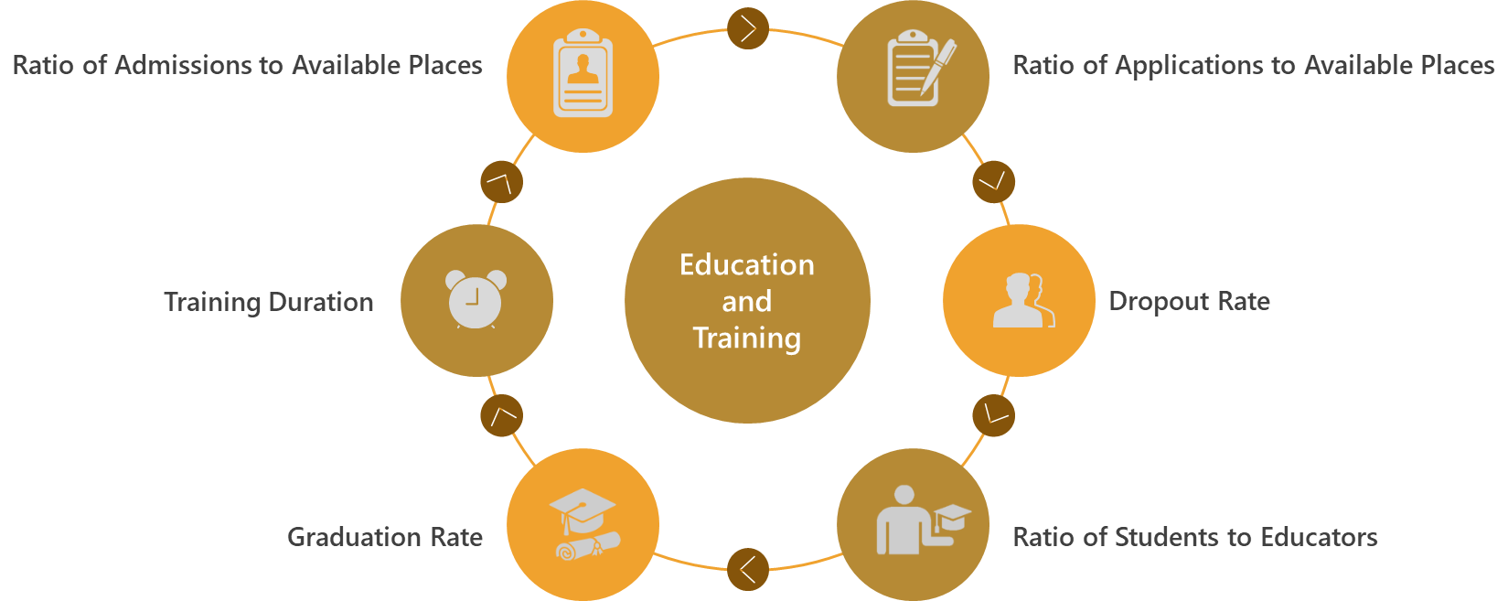
Figure 15 - Module 2 Key Areas

Indicator Data
Indicator Id | 2.01
Unique Reference Id | ID_178
Name | Existence of a master list of accredited health workforce education and training institutions that is up to date and available in the public domain
Possible Values | Yes/No/Partly
Definition | Existence of a master list of accredited health workforce education and training institutions that is up to date and available in the public domain.
Value | Yes
Level | UAE
Data Sources | Ministry of Education (MOE)

Module Summary
Key Summary for Education and Training Regulation & Accreditation
- 3245 applications made in the MOE licensed higher health education and training institutions.
- 8265 enrollments made in the MOE licensed higher health education and training institutions.
- 82.52% of health education graduates are Females majorly specializing in Pharmacy.
- 92.69% of health education graduates studied in Private institutions majorly specializing in Pharmacy.
- Existence of Master List of licensed health education and training institutions.

CHAPTER 6: MODULE 3 - EDUCATION & TRAINING REGULATION AND ACCREDITATION

Overview: This module chiefly focuses on the regulation and accreditation standards for education and training institutes and their programmes and the incorporation of social aspects and inter-professional education in those standards. The benefits of data acquired in this module includes below key areas:
- Solidifies accreditation process of education institutes
- Aids in Inter-sectoral health workforce agenda creation
- Validates national education plan alignment with national health plan
- Assesses skills taught to population needs
- Enhances quality and relevance of education and training

Key Areas
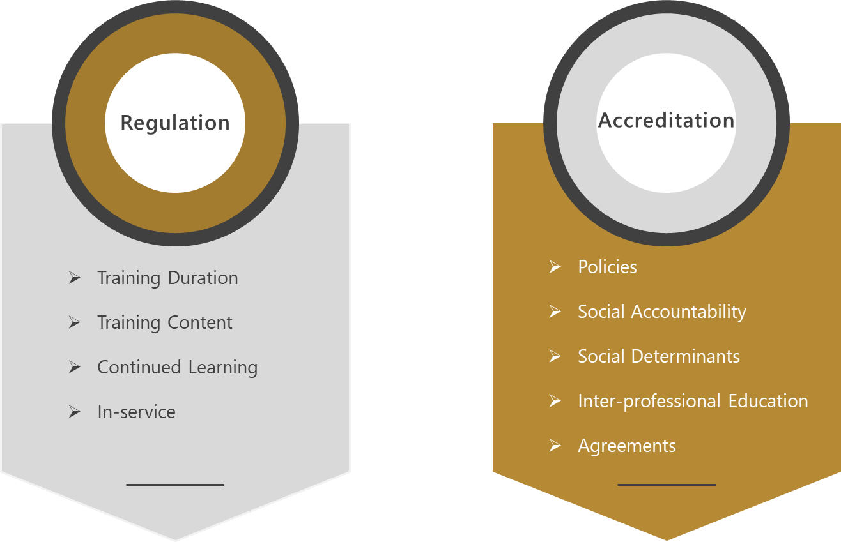
Figure 16 - Module 3 Key Areas

Indicator Data
Indicator Id | 3.01
Unique Reference Id | ID_185
Name | Existence of national and/or subnational standard on the duration and content of health workforce education and training
Possible Values | Yes/No/Partly
Definition | The following questions help determine the existence of national and/or subnational standard on the duration and content of health workforce education and training
  Supporting Question | Answer
  Are entry requirements to health workforce education and training programmes established concerning age, previous studies, previously acquired competence by study and past professional experience? | Yes
  Are the total number of hours to be spent on health workforce education and training established? | Yes
  Is there a list of knowledge, skills and competencies to be acquired during health workforce education and training? | Yes
Value | Yes
Level | UAE
Data Sources | Commission for Academic Accreditation (CAA)

Indicator Id | 3.02
Unique Reference Id | ID_186
Name | Existence of national and/or subnational mechanisms for accreditation of health workforce education and training institutions and their programmes
Possible Values | Yes/No/Partly
Definition | The following questions help determine the existence of national and/or subnational mechanisms for accreditation of health workforce education and training institutions and their programmes
  Supporting Question | Answer
  Have national and/or subnational mechanisms for accreditation of health workforce education and training institutions and their programmes been established? | Yes
  Are national and/or subnational mechanisms for accreditation of health workforce education and training institutions and their programmes compulsory? | Yes
  Are there national and/or subnational mechanisms for accreditation of health workforce education and training institutions and their programmes that are not compulsory? | No
  If established, do national and/or subnational mechanisms for accreditation of health workforce education and training institutions and their programmes take into account national education plans for the health workforce? | Yes
Value | Partly
Level | UAE
Recommendation | ‎23.2.1 Recommendation for Accreditation of non-compulsory education and training institutions
Data Sources | Commission for Academic Accreditation (CAA)

Indicator Id | 3.03
Unique Reference Id | ID_187
Name | Existence of national and/or subnational standards for social accountability in accreditation mechanisms
Possible Values | Yes/No/Partly
Definition | The following questions help determine the existence of national and/or subnational standards for social accountability in accreditation mechanisms
  Supporting Question | Answer
  Is social accountability included or reflected within national and/or subnational standards | Yes
  Is there an involvement of civil society, other social stakeholders and communities in accreditation mechanisms? | Yes
Value | Yes
Level | UAE
Data Sources | Commission for Academic Accreditation (CAA)

Indicator Id | 3.04
Unique Reference Id | ID_188
Name | National and/or subnational standards for social accountability in accreditation mechanisms are effectively implemented
Possible Values | Yes/No/Partly
Definition | The following questions help determine the effective implementation of National and/or subnational standards for social accountability in accreditation mechanisms
  Supporting Question | Answer
  Do national and/or subnational mechanisms for accreditation of health workforce education and training institutions and their programmes require compulsory reporting on implementation of national or subnational standards on social accountability? | Yes
  Do the communities served by the health workforce education and training institutions participate in the decision-making of these institutions? | Yes
  Do students learn and train in the communities that the health workforce education and training institution serves (community placements)? | Yes
  Do health workforce education and training institutions measure their impact on the health system and populations they serve? | Partly
Value | Partly
Level | UAE
Recommendation | ‎23.2.2 Recommendation for measurement of Impact of health training on health system and population
Data Sources | Commission for Academic Accreditation (CAA)  Ministry of Health and Prevention (MOHAP) – Training & Development Centre

Indicator Id | 3.05
Unique Reference Id | ID_189
Name | Existence of national and/or subnational standards for the social determinants of health in accreditation mechanisms
Possible Values | Yes/No/Partly
Definition | The following questions help determine the existence of national and/or subnational standards for the social determinants of health in accreditation mechanisms
  Supporting Question | Answer
  Are the social determinants of health included or reflected within national and/or subnational standards? | Yes
  Do health workforce education and training institutions measure social determinants of health in the populations they serve? | Yes
  Do health workforce education and training institutions adapt curricula according to social determinants of health in their communities? | Yes
Value | Yes
Level | UAE
Data Sources | Commission for Academic Accreditation (CAA)

Indicator Id | 3.06
Unique Reference Id | ID_190
Name | Existence of national and/or subnational standards for interprofessional education in accreditation mechanisms
Possible Values | Yes/No/Partly
Definition | The following questions help determine the existence of national and/or subnational standards for interprofessional education in accreditation mechanisms
  Supporting Question | Answer
  Is interprofessional education included or reflected within national and/or subnational standards? | Partly
Value | Partly
Level | UAE
Recommendation | ‎23.2.3 Recommendation for implementation of accreditation standards for IPE
Data Sources | Commission for Academic Accreditation (CAA)

Indicator Id | 3.07
Unique Reference Id | ID_191
Name | Existence of cooperation between health workforce education and training institutions and regulatory bodies to agree on accreditation standards
Possible Values | Yes/No/Partly
Definition | The following questions help determine the existence of cooperation between health workforce education and training institutions and regulatory bodies to agree on accreditation standards
  Supporting Question | Answer
  Is there a coordinating mechanism or body in place for this task? | Yes
  Are various stakeholders at national and institutional level involved in the coordination process? | Yes
  Are there institutional mechanisms in place to coordinate accreditation systems, including negotiations with relevant ministries, government agencies and stakeholders? | Yes
Value | Yes
Level | UAE
Data Sources | Commission for Academic Accreditation (CAA)

Indicator Id | 3.08
Unique Reference Id | ID_192
Name | Existence of national systems for continuing professional development
Possible Values | Yes/No/Partly
Definition | The following questions help determine the existence of national systems for continuing professional development
  Supporting Question | Answer
  Are there existing national and/or subnational systems for continuing professional development (CPD)? | Yes
  If national and/or subnational systems for CPD exist, are they compulsory | Yes
  If compulsory, are they linked to relicensure? | Yes
  For occupations that have a national and/or subnational system for CPD, is it integrated into national education plans for the health workforce, for that occupation? | No
Value | Partly
Level | UAE
Recommendation | ‎23.2.4 Recommendation for integration of CPD into National Education Plan
Data Sources | Commission for Academic Accreditation (CAA)  Ministry of Health and Prevention (MOHAP) – Training & Development Centre

Indicator Id | 3.09
Unique Reference Id | ID_193
Name | Existence of in-service training as an element of national education plans for the health workforce
Possible Values | Yes/No/Partly
Definition | The following questions help determine the existence of in-service training as an element of national education plans for the health workforce
  Supporting Question | Answer
  Is in-service training integrated into larger national education-wide sector policies, strategies and plans? | Yes
  Does in-service training consider and take into account national policies, strategies and plans for transforming professional, technical and vocational education and training? | Yes
  Does in-service training consider and take into account national policies, strategies and plans for adult learning and higher education? | Yes
Value | Yes
Level | UAE
Data Sources | Commission for Academic Accreditation (CAA)

Module Summary
Key Summary for Active Health Work Stock
- National Standards for entry criteria, hours spent and knowledge outcomes are well defined for Health Education Institutions.
- National Accreditation standards and mechanisms for quality control of Health Education Institutes and their programmes exist with below salient features
  - Defined based on multi-stakeholder and inter-sectoral agreement.
  - Holistic in nature because of inclusion of social accountability and determinants of health.
  - Attuned towards life-long learning due to CPD and Inter-professional education.
- Areas of improvement (We have provided recommendations for these items below)
  - Free zones based medical institutions were exempted from accreditation in 2018 however post Sep 2019 they shall be included under accreditation process by CAA.
  - Impact measurement of health workforce training on population is not in place.
  - IPE is encouraged however not mandatory in the accreditation system.
- Continuing Professional Development standards are not in line with national education plan for health workforce.

CHAPTER 7: MODULE 4 – EDUCATION FINANCES

Overview: This module has data which quantifies public/private expenditure towards health workforce education and training across higher education, continued learning and specialist education. The benefits of data acquired in this module includes below key areas:
- Provides details on health workforce development costs
- Distribution of budget in education, skills and job creation
- Ascertains sustainable financing for continued education and International Health Regulations (IHR) core competencies
Kindly Note - We have not received data for all the indicators of this module. Details are present in section: ‎24.2.3 Module 4 – Education Finances

Key Areas
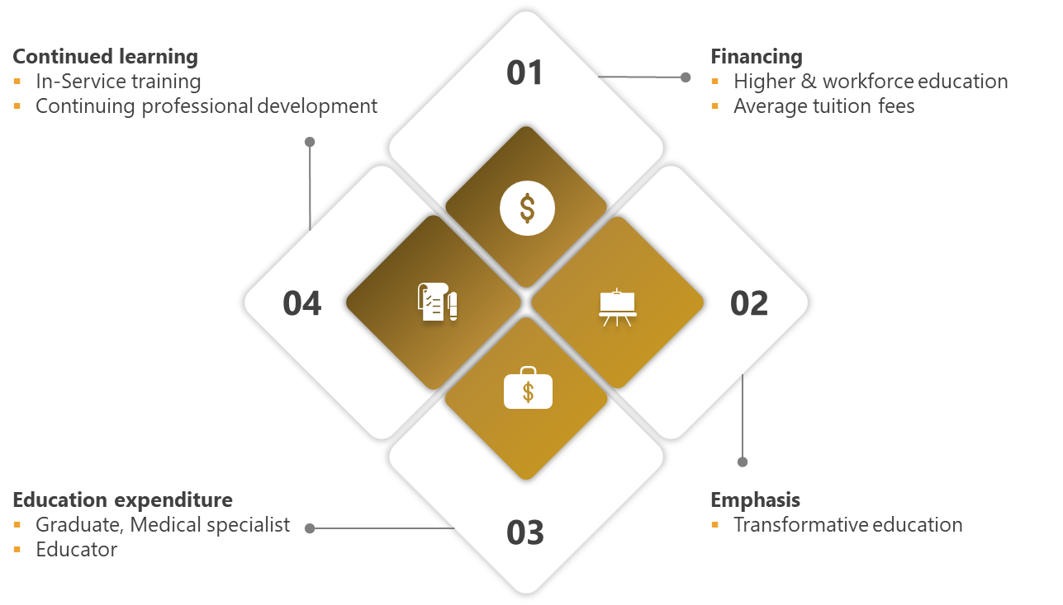
Figure 17 - Module 4 Key Areas

CHAPTER 8: MODULE 5 – HEALTH LABOUR MARKET FLOWS

Overview: This module provides distribution of labour market into entries, voluntary & involuntary exits and imbalances. The defined indicators relate to the GSHRH target on the reduction of access constraints to health services, through the creation, filling and sustenance of jobs in the health and social care sectors. The benefits of data acquired in this module includes below key areas:
- Improved understanding of labour market flows
- Effective recruitment and retention policies to ensure smooth functioning of health sector workforce
- Highlights dependency on foreign workers
- Showcases movement of successful graduates into the health labour market
Kindly Note - We have not received data for all the indicators of this module. Details are present in section: ‎24.2.4 Module 5 – Health Labour Market Flows

Key Areas
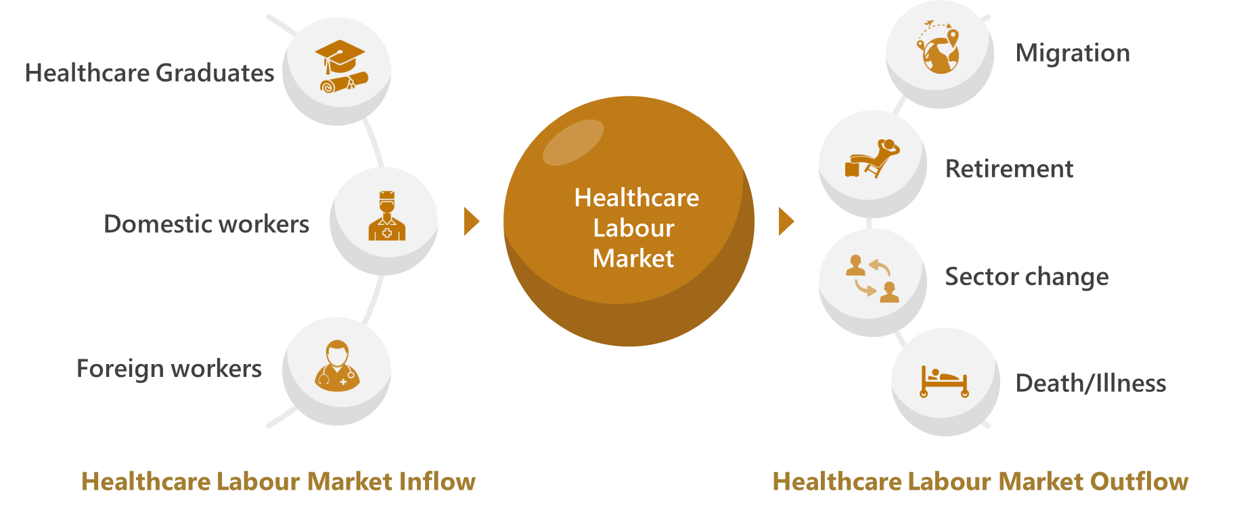
Figure 18 - Module 5 Key Areas

CHAPTER 9: MODULE 6 – EMPLOYMENT CHARACTERISTICS AND WORKING CONDITIONS

Overview: This module highlights regulations affecting working conditions and employment practices. It can facilitate comprehensive labour market assessment in conjunction with Module 5.
This module also focusses on self-employed and part time employee characteristics. The benefits of data acquired in this module includes below key areas:
- Progressive review of causal and descriptive labour market analyses
- Policies promoting work-life balance
- Provides inputs towards respectful working conditions
- Stresses upon health provider and facility safety based on prevention measures for health care worker and system attacks
Kindly Note - We have not received data for few indicators of this module. Details are present in section: ‎24.2.5 Module 6 – Employment Characteristics and Working Conditions

Key Areas
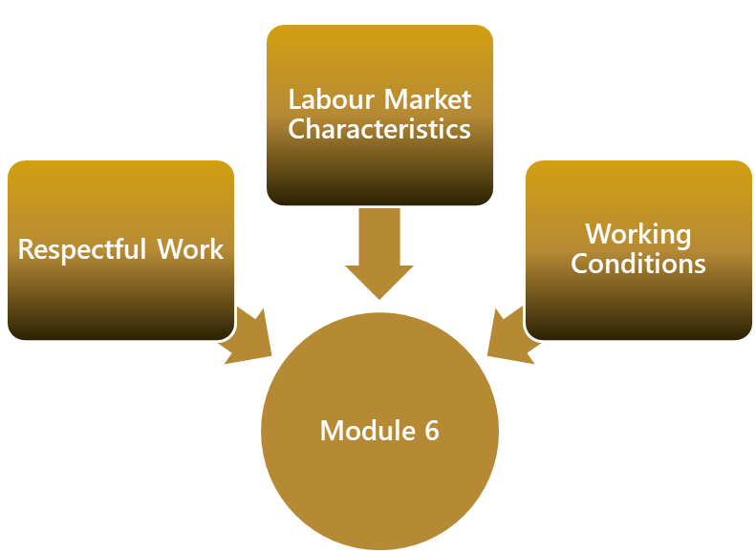
Figure 19 - Module 6 Key Areas

Indicator Data
Indicator Id | 6.01
Unique Reference Id | ID_209
Name | Number of standard working hours per week as per national law/standards
Definition | Number of standard working hours per week as per national law/standards.
Value | 48
Unit | Hours per week
Level | UAE Public Sector
Data Sources | Ministry of Health and Prevention (MOHAP)

Indicator Id | 6.03
Unique Reference Id | ID_211
Name | Existence of national/subnational policies/laws regulating working hours and conditions
Possible Values | Yes/No/Partly
Definition | The following questions help determine the existence of national/subnational policies/laws regulating working hours and conditions
  Supporting Question | Answer
  Has the government and its competent authorities regulated the maximum number of working days allowed per week? | Yes
  Has the government and its competent authorities regulated the premium for night work, for work on a weekly rest day, for overtime work (as a percentage of hourly pay)? | Yes
  Has the government and its competent authorities regulated whether non-pregnant and non-nursing women can work the same night hours as men? | Yes
  Has the government and its competent authorities regulated whether there are restrictions on night work, overtime or holiday work? | Yes
  Has the government and its competent authorities regulated the average paid annual leave for workers with 1, 5 and 10 years of tenure? | Yes
  Has the government and its competent authorities regulated whether regulations, laws or policies differ according to employment status? | Yes
Value | Yes
Level | UAE Public Sector
Data Sources | Federal Authority for Government Human Resources (FAHR)

Indicator Id | 6.05
Unique Reference Id | ID_213
Name | Existence of national/subnational policies/laws regulating social protection
Possible Values | Yes/No/Partly
Definition | The following questions help determine the existence of national/subnational policies/laws regulating social protection
  Supporting Question | Answer
  Is there a national policy or programme regarding maternity leave or pregnancy leave? | Yes
  Is there a national policy or programme regarding parental leave? | Yes
  Is there a national policy or programme regarding childcare support? | Yes
  Is there a national policy or programme regarding leave entitlements to care for sick family members? | Yes
  Is there a national policy or programme regarding leave entitlements for in-service training and continuing professional development? | Yes
Value | Yes
Level | UAE Public Sector
Data Sources | Federal Authority for Government Human Resources (FAHR)

Module Summary
Key Summary for employment characteristics and working conditions
- 48 Hours per week is the standard defined for public sector.
- Well defined gender-neutral policies exist in public sector for below areas
  - Regulation of working hours in inclusive of Night shifts, Overtime and Holiday work.
  - Regulation of social protection in terms of leaves due to maternity, childcare, sick family members and training (In-Service and CPD).
- Consistent work hour regulations for females especially in terms of extra work and night hours.
- Well-defined regulations for part-time worker permit.

CHAPTER 10: MODULE 7 - HEALTH WORKFORCE SPENDING & REMUNERATION

Overview: This module focuses on public/private expenditure on health workforce and definition of regulation and policies towards worker compensation. In conjunction with module 4 the cumulative data provides a summary of the financial environment of health workforce. The benefits of data acquired in this module includes below key areas:
• Emphasis on monitoring Gender Pay Gap
• Economic analysis on flow of funds in health workforce
• Crucial information for budget allocation with government entities
Kindly Note - We have not received data for few indicators of this module. Details are present in section: ‎ 24.2.6 Module 7 – Health Workforce Expenditure

Key Areas
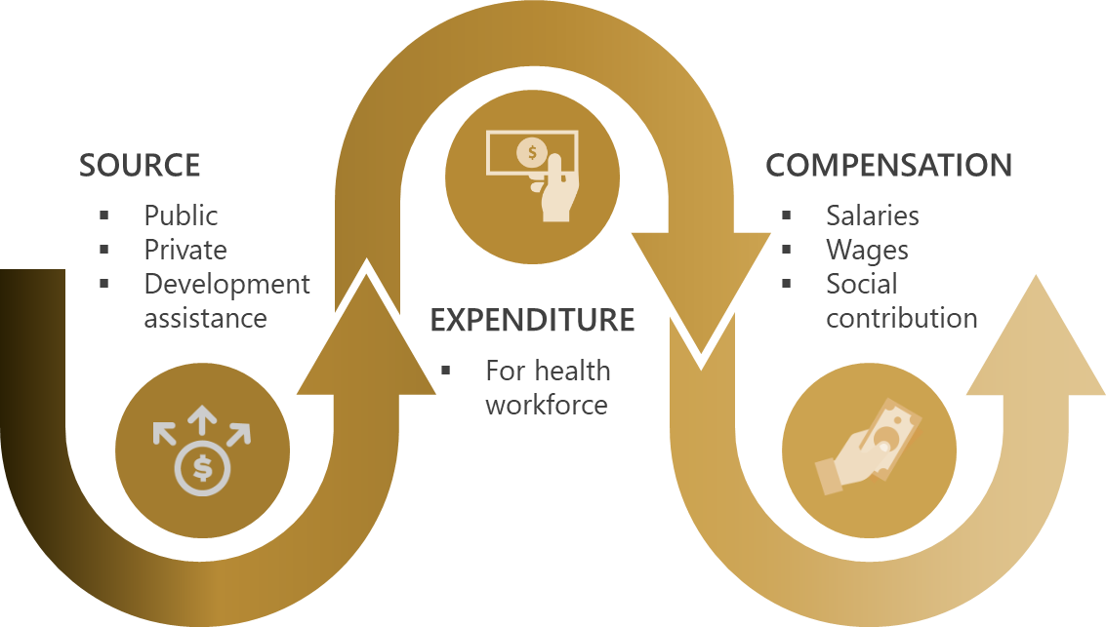
Figure 20 - Module 7 Key Areas

Indicator Data
Indicator Id | 7.06
Unique Reference Id | ID_224
Name | Existence of national/subnational policies or standards on public sector wage ceilings
Possible Values | Yes/No
Definition | Existence of national/subnational policies or standards on public sector wage ceilings. Such policies would generally be applicable not only to the health sector, but to the whole public sector.
Value | Yes
Level | UAE Public Sector
Data Sources | Ministry of Health and Prevention (MOHAP)

Indicator Id | 7.07
Unique Reference Id | ID_225
Name | Gender wage gap
Definition | The gender wage gap is the unadjusted difference between median earnings of men and women relative to median earnings of men. Data refer to full-time employees and to the self-employed.
Numerator | Difference between median earnings of men and women
Denominator | Median earnings of men
Value | 0
Unit | Percent (%)
Level | UAE Public Sector - Partial
Data Sources | Ministry of Health and Prevention (MOHAP)

Module Summary
Key Summary for Health Workforce Expenditure and Remuneration
- There is no gender wage disparity in MOHAP based institutions.
- There is existence for public sector wage ceiling for controlling maximum salary values that can be earned by health employees however exceptions are made for special expert contracts.

CHAPTER 11: MODULE 8 - SKILL-MIX COMPOSITION FOR MODELS OF CARE

Overview: This module contains indicators which distribute the structure of health workforce by sector facility and specialized skill set. Data obtained from this module helps ascertains human resource capacity for International Health Regulation (IHR) and Field Epidemiology programs. The benefits of data acquired in this module includes below key areas:
- Matching labour supply with health care needs of population
- Skill-mix to case-mix alignment for patient centered care
- Compliance with International Health Regulations (IHR)

Key Areas

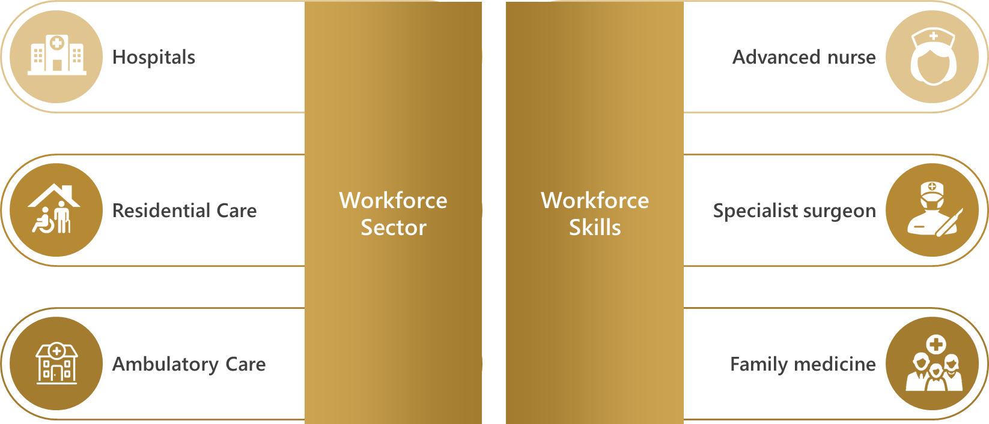
Figure 21 - Module 8 Key Area

Indicator Data
Indicator Id | 8.01
Unique Reference Id | ID_226
Name | Percentage of health workforce working in hospitals
Definition | Percentage of health workers working in hospitals among all health workers. Hospitals are defined as all types of hospitals, following the International Classification for Health Accounts 2011 (including General hospitals, Mental health hospitals, and Other specialized hospitals).
Numerator | Total number of active health workers working in hospitals
Denominator | Total number of active health workers
Value | 47.45
Unit | Percent (%)
Level | UAE Public Sector - Partial
Data Sources | Ministry of Health and Prevention (MOHAP)  Ministry of Presidential Affairs (MOPA)  Department of Health (DOH)

Indicator Id | 8.02
Unique Reference Id | ID_227
Name | Percentage of health workforce working in residential long-term care facilities
Definition | Percentage of health workers, excluding social care workers, working in residential long-term care among all health workers. A residential long-term care facility is any type of nursing and residential care facility defined in the HP2.1 and HP2.9 categories of the International Classification for Health Accounts 2011.
Numerator | Total number of active health workers working in residential long-term care facilities
Denominator | Total number of active health workers
Value | 1.41
Unit | Percent (%)
Level | UAE Public Sector - Partial
Data Sources | Ministry of Health and Prevention (MOHAP)  Ministry of Presidential Affairs (MOPA)  Department of Health (DOH)

Indicator Id | 8.03
Unique Reference Id | ID_228
Name | Percentage of health workforce working in ambulatory health care (primary health care level facilities)
Definition | Percentage of health workforce working in ambulatory health care presumed to be primary health care level facilities. Ambulatory care provision refers to individuals and organizations that deliver personal healthcare services on an outpatient basis. This includes diagnosis, observation, consultation, treatment, intervention, rehabilitation services, and advanced medical technology and procedures even when provided outside of hospitals.
Numerator | Total number of active health workers working in ambulatory health care presumed to be primary health care level facilities
Denominator | Total number of active health workers
Value | 30.99
Unit | Percent (%)
Level | UAE Public Sector - Partial
Data Sources | Ministry of Health and Prevention (MOHAP)  Ministry of Presidential Affairs (MOPA)  Department of Health (DOH)

Indicator Id | 8.04
Unique Reference Id | ID_229
Name | Density of specialist surgical workers per 100 000 population
Definition | Density of specialist surgical workers, classified in ISCO-08 with code 2212, per 100 000 population. Specialist surgical workers are surgeons, obstetricians and anesthesiologists
Numerator | Total number of specialist surgical workers
Denominator | Total population
Value | 62.64
Unit | Per 100 000 population
Level | UAE
Data Sources | Ministry of Health and Prevention (MOHAP)  Department of Health (DOH)  Dubai Health Authority (DHA)  Dubai Healthcare City (DHCC)  Ministry of Presidential Affairs (MOPA)

Indicator Id | 8.05
Unique Reference Id | ID_230
Name | Density of family medicine practitioners per 100 000 population
Definition | Density of family medicine practitioners per 100 000 population. Family medicine practitioners are part of the generalist medical practitioners. They are referred to as general practitioners in some countries, and as a specialization in others. They should provide person-centred, continuous and comprehensive medical care to individuals and families in their communities. This group does not include resident medical officers, medical interns or other generalist medical practitioners not in general practice activities.
Numerator | Total number of family medicine practitioners
Denominator | Total population
Value | 81.45
Unit | Per 100 000 population
Level | UAE
Data Sources | Ministry of Health and Prevention (MOHAP)  Department of Health (DOH)  Dubai Health Authority (DHA)  Dubai Healthcare City (DHCC)  Ministry of Presidential Affairs (MOPA)

Indicator Id | 8.06
Unique Reference Id | ID_231
Name | Existence of advanced nursing roles
Possible Values | Yes/No/Partly
Definition | The following questions help determine the existence of advanced nursing roles
  Supporting Question | Answer
  Is there a commonly accepted definition of ‘nurse practitioner’? | Yes
  Is there another commonly accepted definition of other types of nurses working in advanced roles? | Yes
  Are there formal requirements to become a nurse practitioner or other type of advanced practice nurse in terms of specified training, qualifications, experience, certification/registration, etc.? | Yes
  Are there ad-hoc/local methods for nurses being trained “on the job” to acquire specific skills that could lead to their employment in advanced roles? | No
Value | Partly
Level | UAE
Recommendations | ‎25.2.6 Recommendation for accreditation of in-service training programmes for advancing roles of Nurses
Data Sources | Ministry of Health and Prevention (MOHAP)

Indicator Id | 8.07
Unique Reference Id | ID_232
Name | Availability of human resources to implement International Health Regulation core capacity requirements
Possible Values | None/ Limited/ Developed/ Demonstrated/ Sustainable Capacity
Definition | This indicator is measured (or supported) by the following (capability) items:
  Capability Item | Capability Value
  No multidisciplinary human resource capacity available to implement IHR core capacities | No capacity
  Multidisciplinary human resource capacity (epidemiologists, veterinarians, clinicians and laboratory specialists or technicians) available at national level | Limited capacity
  Multidisciplinary human resource capacity available at national developed capacity and intermediate level | Developed capacity
  Multidisciplinary human resource capacity available as required at relevant levels of public health system (e.g. epidemiologist at national and intermediate level and assistant epidemiologist (or short course trained epidemiologist) at local level available) | Demonstrated capacity
  Capacity to send and receive multidisciplinary personnel within country (shifting resources) and internationally | Sustainable capacity
Value | Sustainable capacity
Level | UAE Public Sector
Data Sources | Ministry of Health and Prevention (MOHAP)

Indicator Id | 8.08
Unique Reference Id | ID_233
Name | Existence of an applied epidemiology training programme
Possible Values | None/ Limited/ Developed/ Demonstrated/ Sustainable Capacity
Definition | This indicator is measured (or supported) by the following (capability) items:
  Capability Item | Capability Value
  No Field Epidemiology Training Programme (FETP) or applied epidemiology training programme established | No capacity
  No FETP or applied epidemiology training programme is established within the country, but staff participate in a programme hosted in another country through an existing agreement (at basic, intermediate and/or advanced level | Limited capacity
  One level (basic, intermediate, advanced) of FETP or comparable applied epidemiology training programme in place in the country or in another country through an existing agreement | Developed capacity
  Two levels (basic, intermediate and/or advanced) of FETP or comparable applied epidemiology training programme(s) in place in the country or in another country through an existing agreement | Demonstrated capacity
  Three levels (basic, intermediate, advanced) of FETP or comparable applied epidemiology training programme(s) in place in the country or in another country through an existing agreement, with sustainable national funding | Sustainable capacity
Value | Limited capacity
Level | UAE Public Sector
Recommendations | ‎23.2.5 Recommendation for capacity of Field Epidemiology Training Programmes
Data Sources | Ministry of Health and Prevention (MOHAP)

Module Summary
Key Summary for Skill-mix composition for models of care
- 47.45% of healthcare professionals work in Hospital settings.
- Density of Specialist Surgical workers is 62.64 per 100 000 population.
- Density of Family Medicine workers is 81.45 per 100 000 population.
- There is a Sustainable Capacity of human resources for reporting for International Health Regulations (IHR) core capacity requirements.
- There is a Limited Capacity of Field Epidemiology Training Programmes (FETP).
- There is existence of Advanced Nursing roles.

CHAPTER 12: MODULE 9 - GOVERNANCE AND HEALTH WORKFORCE POLICIES

Overview: This module focuses on governance and policies for effective management of health workforce planning. The governance indicators reveal a country’s ability to able to coordinate an inter-sectoral health workforce agenda and possession of central HWF unit. The indicators on health workforce policies provide information on whether the country possesses health workforce planning process. The benefits of data acquired in this module includes below key areas:
- Demonstrates effective use and application of information collected from other modules
- Confirms alignment of national education plans with national health plans

Key Areas

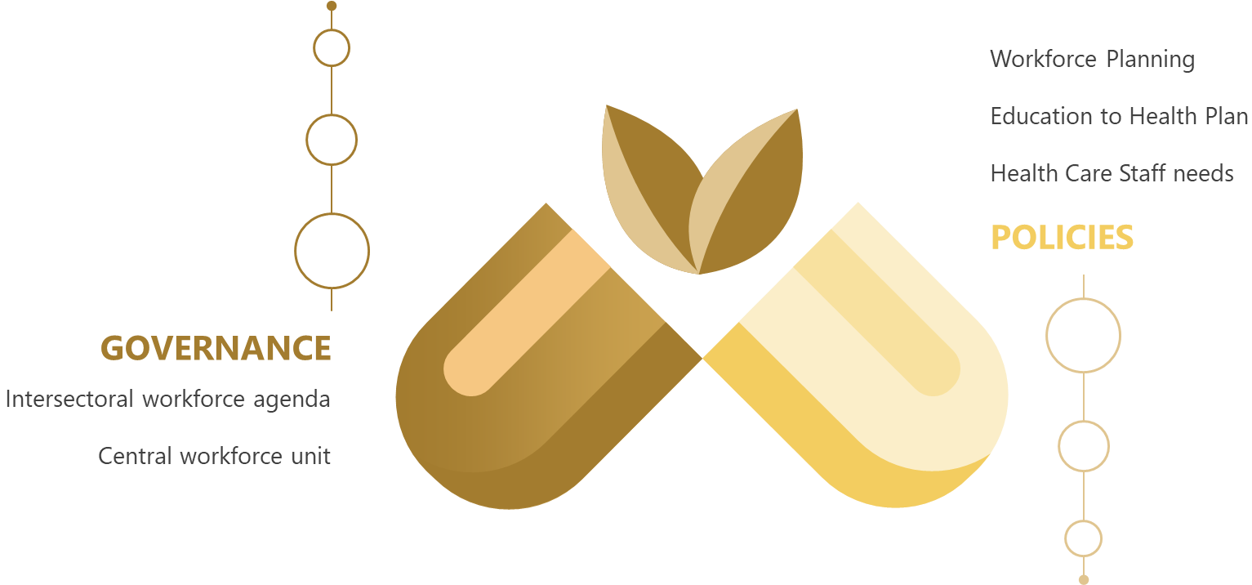
Figure 22 - Module 9 Key Areas

Indicator Data
Indicator Id | 9.01
Unique Reference Id | ID_234
Name | Existence of institutional mechanisms or bodies to coordinate an intersectoral health workforce agenda
Possible Values | Yes/No/Partly
Definition | The following questions help determine the existence of institutional mechanisms or bodies to coordinate an inter-sectoral health workforce agenda
  Supporting Question | Answer
  Is there a coordinating mechanism or body in place for this task? | Yes
  Are various stakeholders (ministries, public, private, nongovernmental and, international bodies) involved in the coordination process? | Yes
  Has an agenda been formulated? | Yes
  Has the agenda been approved at interministerial level (ministries of Education, Finance, Public Service, Health)? | Yes
Value | Yes
Level | UAE Public Sector
Data Sources | Ministry of Health and Prevention (MOHAP) – Public Policies Department

Indicator Id | 9.02
Unique Reference Id | ID_235
Name | Existence of a health workforce unit in the Ministry of Health responsible for developing and monitoring policies and plans on health workforce
Possible Values | Yes/No/Partly
Definition | The following questions help determine the existence of a health workforce unit in the Ministry of Health responsible for developing and monitoring policies and plans on health workforce
  Supporting Question | Answer
  Are there functions to monitor health workforce policies and plans as part of the monitoring of health services development? | Yes
  Are there institutional mechanisms in place to coordinate an intersectoral health workforce agenda, including negotiations and intersectoral relationships with relevant other line ministries, government agencies and stakeholders? | Yes
Value | Yes
Level | UAE Public Sector
Data Sources | Ministry of Health and Prevention (MOHAP) – Public Policies Department

Indicator Id | 9.03
Unique Reference Id | ID_236
Name | Existence of mechanisms and models for health workforce planning
Possible Values | Yes/No/Partly
Definition | The following questions help determine the existence of mechanisms and models for health workforce planning
  Supporting Question | Answer
  Are clear and explicit health workforce planning objectives set up in the national health policy? | Yes
  Is there a coordinated communication and information flow among national-level intersectoral stakeholders? | Yes
  Is there a dedicated and established Human Resources for Health Planning Committee, a designated entity or a specific group at the national level responsible for the HWF? | Yes
  Is there a methodology established for HWF planning? | Yes
  Are complete data with full coverage of the population available in a sustainable manner to provide quantitative assessment required for HWF planning? | Yes
  Are policy actions based on the recommendations of the HWF Planning Committee implemented? | Yes
Value | Yes
Level | UAE Public Sector
Data Sources | Ministry of Health and Prevention (MOHAP) – Public Policies Department

Indicator Id | 9.04
Unique Reference Id | ID_237
Name | Existence of national education plans for the health workforce, aligned with the national health plan and the national health workforce strategy/plan
Possible Values | Yes/No/Partly
Definition | The following questions help determine the existence of national education plans for the health workforce, aligned with the national health plan and the national health workforce strategy/plan
  Supporting Question | Answer
  Do education plans for the HWF match health worker competencies with population, health systems, and health labour market needs? | Yes
  Do plans take into account efforts to scale up transformative education and training? | Yes
  Do recognized institutes such as national public health institutes, universities and collaborating centres offer training courses on the implementation and monitoring of Health in All Policies and related concepts? | Yes
  Are strategic steps taken when considering and taking into account the workforce market needs and absorptive capacities for the education plan development? | Yes
Value | Yes
Level | UAE Public Sector
Data Sources | Ministry of Health and Prevention (MOHAP) – Public Policies Department

Indicator Id | 9.05
Unique Reference Id | ID_238
Name | Existence of institutional models for assessing and monitoring staffing needs for health service delivery
Possible Values | Yes/No/Partly
Definition | The following questions help determine the existence of institutional models for assessing and monitoring staffing needs for health service deliver
  Supporting Question | Answer
  Is there a mechanism and/or responsible body in charge of determining the number of health workers of a particular occupation required to effectively and safely deliver health services in health facilities? | Yes
  Is there a mechanism to assess the workload of health workers in health facilities? | Yes
Value | Yes
Level | UAE Public Sector
Data Sources | Ministry of Health and Prevention (MOHAP) – Public Policies Department

Module Summary
Key Summary for Governance and Health Workforce policies
- Below mentioned are key institutional mechanisms for Health Workforce Governance
  - Co-ordinated inter-sectoral health workforce agenda cutting across federal and private regulatory entities.
  - Central Health Workforce Unit in the Ministry of Health.
- Below mentioned are key aspects for Health Workforce Planning
  - Defined objectives, inter-sectoral stakeholders and committees involved in the health workforce planning processes.
  - Alignment of National Education Plan with the National Health Workforce Plan.
  - Structure in place for monitoring quantity and workload of health workers.

CHAPTER 13: MODULE 10 – HEALTH WORKFORCE INFORMATION SYSTEMS

Overview: This module defines indicators on the status of human resource for health information systems (HRHIS) systems for checking their reporting abilities against key regulations like IHR, WHO Code of Practise etc and tracking of data pertaining to labour market areas. The benefits of data acquired in this module includes below key areas:
• Ascertains readiness of HRHIS for meeting international reporting requirements on health workforce
• Tracking of entry, stock and exit of resources from labour market
• Production of geocoded facility location data
Kindly Note - We have not received data for an indicator of this module. Details are present in section: ‎24.2.7 Module 10 – Health Workforce Information Systems

Key Areas

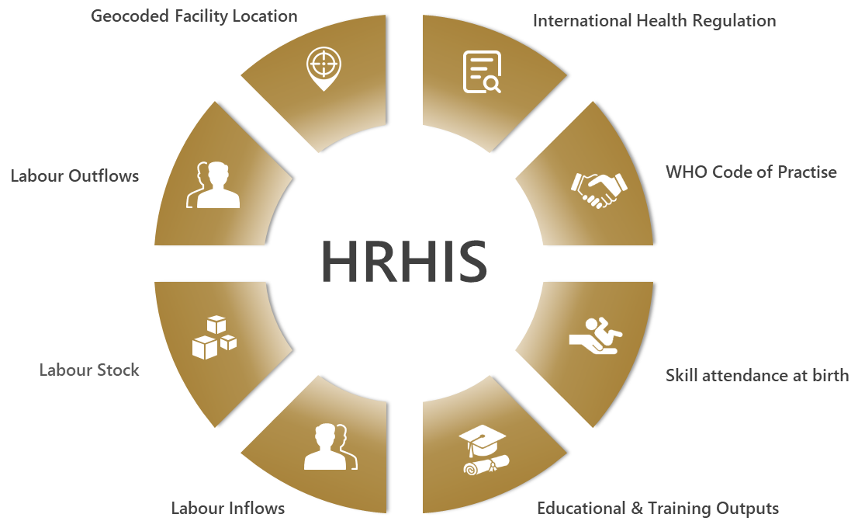
Figure 23 - Module 10 Key Areas

Indicator Data
Indicator Id | 10.01
Unique Reference Id | ID_239
Name | Ability of HRHIS to generate information to report on International Health Regulations
Possible Values | Yes/No/Partly
Definition | The following questions help determine whether HRHIS has the capacity to report on IHR and submit core indicators to the WHO Secretariat annually.
Value | No
Level | UAE Public Sector
Recommendation | ‎23.2.7 Recommendation for reporting capabilities of HRHIS for IHR
Data Sources | Ministry of Health and Prevention (MOHAP)

Indicator Id | 10.03
Unique Reference Id | ID_241
Name | Ability of HRHIS to generate information for reporting on skilled attendance at birth requirements
Possible Values | Yes/No/Partly
Definition | The following questions help determine whether HRHIS has ability to generate information for reporting on skilled attendance at birth requirements.
Value | No
Level | UAE Public Sector
Recommendation | ‎23.2.8 Recommendation for reporting capabilities of HRHIS for Skilled attendance at birth
Data Sources | Ministry of Health and Prevention (MOHAP)

Indicator Id | 10.04
Unique Reference Id | ID_242
Name | Ability of HRHIS to generate information for reporting on outputs from education and training institutions
Possible Values | Yes/No/Partly
Definition | The following questions help determine whether the HRHIS has the capacity to report on outputs from education and training institutions, and submit core indicators to the WHO Secretariat annually
  Supporting Question | Answer
  Is there a master list of accredited education and training institutions at national level? | No
  If yes, is this master list geocoded? | No
  Is this master list updated on a regular basis? | No
  Do education and training institutions record the number of graduates by health workforce education and training, and by sex? | No
  Is information on the number of graduates provided to the relevant national body on an annual basis? | No
Value | No
Level | UAE Public Sector
Recommendation | ‎23.2.10 Recommendation for HRHIS in reporting on outputs from education and training institutions
Data Sources | Ministry of Health and Prevention (MOHAP)

Indicator Id | 10.05
Unique Reference Id | ID_243
Name | Ability of HRHIS for tracking the number of entrants to the labour market
Possible Values | Yes/No/Partly
Definition | The following questions help determine whether the HRHIS has ability for tracking the number of entrants to the labour market
  Supporting Question | Answer
  Is there a system that provides information about the health workforce? | Yes
  If yes, does this system provide information on the inflows of the health labour market? | Yes
Value | Yes
Level | UAE Public Sector
Data Sources | Ministry of Health and Prevention (MOHAP)

Indicator Id | 10.06
Unique Reference Id | ID_244
Name | Ability of HRHIS to generate information to track active stock on the labour market
Possible Values | Yes/No/Partly
Definition | The following questions help determine whether HRHIS has ability to generate information to track active stock on the labour market
  Supporting Question | Answer
  Is there a system that provides information about the health workforce? | Yes
  If yes, does this system provide information on the stock of the health labour market? | Yes
Value | Yes
Level | UAE Public Sector
Data Sources | Ministry of Health and Prevention (MOHAP)

Indicator Id | 10.07
Unique Reference Id | ID_245
Name | Ability of HRHIS to generate information to track exits from the labour market
Possible Values | Yes/No/Partly
Definition | The following questions help determine whether HRHIS has the ability to generate information to track exits from the labour market
  Supporting Question | Answer
  Is there a system that provides information about the health workforce? | Yes
  If yes, does this system provide information on the inflows of the health labour market? | Yes
Value | Yes
Level | UAE Public Sector
Data Sources | Ministry of Health and Prevention (MOHAP)

Indicator Id | 10.08
Unique Reference Id | ID_246
Name | Ability of HRHIS to generate geocoded information on the location of health facilities
Possible Values | Yes/No/Partly
Definition | The following questions help determine whether HRHIS has the ability to generate geocoded information on the location of health facilities
Value | No
Level | UAE Public Sector
Recommendation | ‎23.2.9 Recommendation for HRHIS production of geocoded health facility locations
Data Sources | Ministry of Health and Prevention (MOHAP)

Module Summary
Key Summary for Governance and Health Workforce policies
- The Bayanati (HRHIS System) has data for tracking Entries, Stock and Exits from Health Labour Market.
- Above HRHIS system does not track data pertaining to outputs from Health Education & Training institutes and geocoded health facility locations.
- Currently there is a manual email based reporting process for IHR reporting to WHO.
- Skilled attendance at birth reporting is currently handled by Wareed (HIS System) of MOHAP.
- Geocoded facility locations are currently present in MOHAP Licensing System.

CHAPTER 14: NHWA INTERNATIONAL COMPARISONS

Overview
Key NHWA health workforce indicators are presented here pertaining to Gender Distribution and Category-wise health worker density per 10 000 population.
UAE’s performance in these Indicators against top five countries are presented below to ascertain global health workforce comparability.
Note: All the indicator data present in this chapter are obtained from (WHO - Global Health Workforce Statistics,).

Gender Distribution Indicator
We are measuring gender distribution based on difference between percentage of male workforce and percentage of female workforce.

Medical Doctor
As per below mentioned countries, the gap in Medical Doctors workforce between men and women is highest in UAE with 17.35%.
In Norway there is lowest gender distribution parity in Medical Doctor workforce with small gap of 0.13%

Figure 24 - Medical Doctor - Global Gender Comparison

Nursing
As per below mentioned countries, the gap in Nursing workforce between men and women is highest in Ireland with -98.04%
In UAE the gap between men and women in the Nursing workforce is -62.22%

Figure 25 - Nurses - Global Gender Comparison

Category-wise Health Worker Density indicator

Medical Doctor per 10 000 population
As per below mentioned countries, highest Medical Doctor density per 10 000 population is in Lithuania with 63.53. In the UAE this figure is at 26.

Figure 26 - Global Medical Doctor densities

Nurses and Midwifery per 10 000 population
As per below mentioned countries, highest Nurse and Midwife density per 10 000 population is in Belgium with 194.61. In the UAE this figure is at 59.

Figure 27 - Global Nurse and Midwife Density

Dentists per 10 000 population
As per below mentioned countries, highest Dentists density per 10 000 population is in UAE with 7. Second highest dentist worker density per 10 000 population is in Paraguay with 1.64.

Figure 28 - Global Dentists Density

Pharmacists per 10 000 population
As per below table, Highest Pharmacist density per 10 000 population is in Belgium with 19.07. In the UAE this figure is at 9.

Figure 29 - Global Pharmacist Density

Key Summary for UAE
- Increase required in Female Medical Doctors staff.
- Increase required in overall density of Medical Doctors, Nurses and Pharmacists.

CHAPTER 15: MOHAP RECOMMENDATIONS

Overview
The NHWA modules have certain indicators which are qualitative in nature and are used to assess the capabilities of a country’s health workforce policies and regulations in improving the state of the health workforce. In the above-mentioned chapters pertaining to individual NHWA Modules, certain indicators are in the form of questions which have possible responses as Yes, No or Partly.
For those indicators wherein identified stakeholders have provided responses as No or Partly, We at MOHAP have analyzed those responses and are providing recommendations towards those questions whereby 100% indicator compliance can be achieved in UAE.

Capability Indicator Status
# | Module | Total |  | Yes |  | No |  | Partly
2 | Education & training |  | 1 |  | 1 |  | 0 |  | 0
3 | Education & training regulation and accreditation |  | 9 |  | 5 |  | 0 |  | 4
4 | Education finances |  | 1 |  | 0 |  | 0 |  | 0
6 | Employment characteristics and working conditions |  | 6 |  | 2 |  | 0 |  | 0
7 | Health workforce spending and remunerations |  | 1 |  | 1 |  | 0 |  | 0
8 | Skill-mix composition for models of care |  | 3 |  | 1 |  | 1 |  | 1
9 | Governance and health workforce policies |  | 5 |  | 5 |  | 0 |  | 0
10 | Health workforce information systems |  | 8 |  | 4 |  | 3 |  | 0
Table 12 - Capability Indicator Status

MOHAP Recommendations

Recommendation for Accreditation of non-compulsory education and training institutions
Indicator | Accreditation mechanisms for education and training institutions and their programmes
Question | Are there national and/or subnational mechanisms for accreditation of health workforce education and training institutions and their programmes that are not compulsory?
Recommendation | - This question ascertains non-compulsory areas for accreditation of health workforce education and training institutions and their programmes.  - For the year 2018, the accreditation standards were exempted for education and training institutes that fall under the free zones in UAE.  - Education areas such as governance, student faculty, facilities, research, legal compliance etc. mentioned below need to be accredited periodically to ensure standardized, high quality and relevant education is being imparted.
Post Aug 2019, Ministry of Education should have unveiled a new set of licensing and accreditation standards for all types of higher education institutions which would include free zones in the UAE.

Recommendation for measurement of Impact of health training on health system and population
Indicator | Standards for social accountability effectively implemented
Question | Do health workforce education and training institutions measure their impact on the health system and populations they serve?
Recommendation | - This question verifies whether health workforce education and training institutions measure their impact on the health system and populations they serve.  - In the UAE, healthcare training institutions except Universities and Colleges, measure their medical professionals’ impact on health system and populations served.  - Assessment of their graduates/interns should be undertaken based on areas such as patient outcome, equipment handling, adherence to facility rules, cost effectiveness and other critical performance areas mentioned below.
Above feedback mechanism should be made mandatory for all licensed institutions and carried out on annual basis for identification of potential gaps or improvement areas in training process or educational course material.

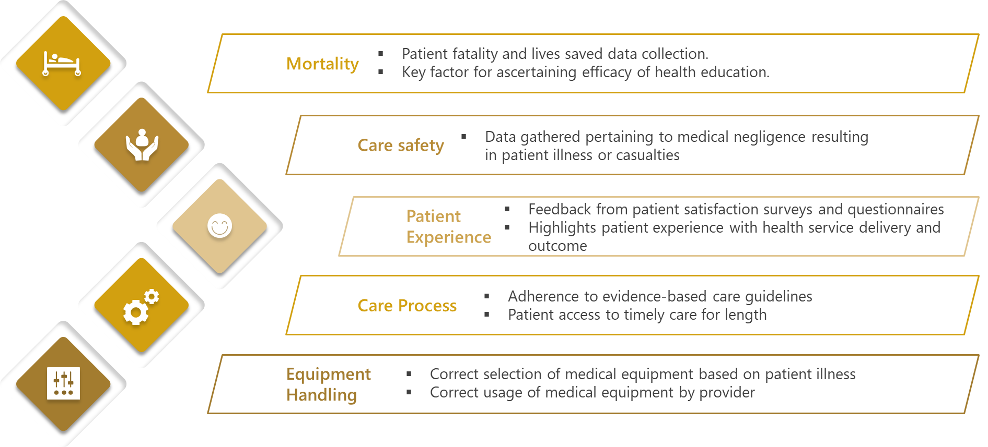
Figure 30 - Implementation Areas for measurement of education and training on health systems and population served

Recommendation for implementation of accreditation standards for IPE
Indicator | Standards for interprofessional education (IPE)
Question | Is interprofessional education included or reflected within national and/or subnational standards?
Recommendation | - This question deals with inclusion of standards for IPE education in educational accreditation.  - IPE education is a collaborative approach to learning resulting in improved knowledge and health outcomes.  - IPE is regarded as an integral mitigation strategy towards global health workforce crisis which takes place in many different countries and healthcare settings across a range of income categories.  - In the UAE, IPE is encouraged but not mandatory for health education universities.
Series of steps detailed below should be undertaken by licensed health education universities in order for successful accreditation of their IPE implementation.

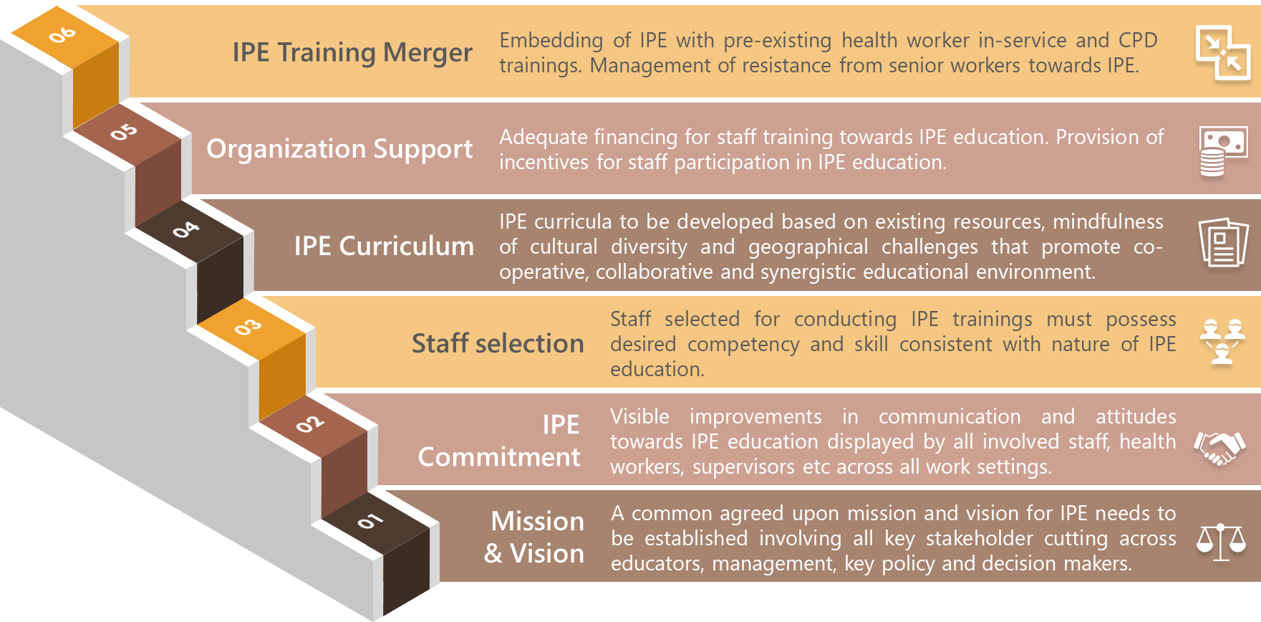
Figure 31 - Steps for accreditation of IPE

Recommendation for integration of CPD into National Education Plan
Indicator | Continuing Professional Development
Question | For occupations that have a national and/or subnational system for CPD, is it integrated into national education plans for the health workforce, for that occupation?
Recommendation | - This question indicator verifies the incorporation of CPD into the national education plan for health workforce.  - CPD is used to describe learning activities that professionals partake in to develop and enhance their skills.  - Currently the CPD standards for health workforce education are not integrated with national education plan.
A standard structure for CPD needs to be established in order to ensure complete training and development of every individual healthcare worker along with certification for essential re-licensure.

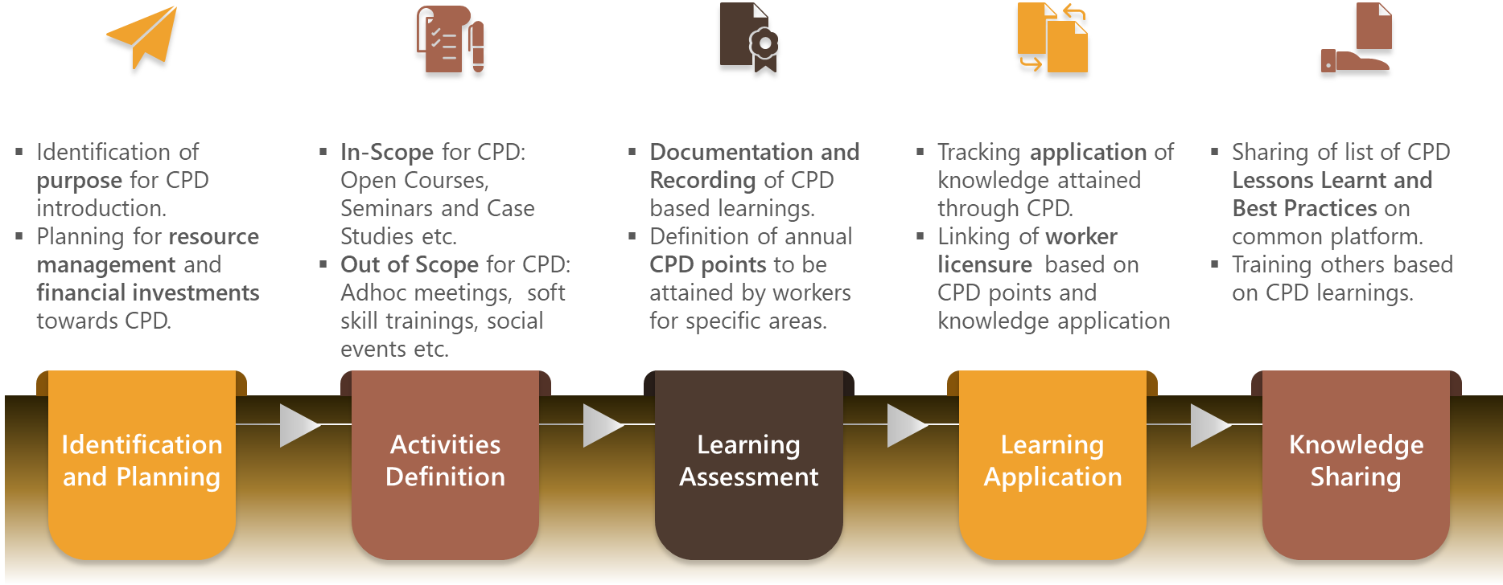
Figure 32 – CPD Inclusion process in National Education Plan

Recommendation for capacity of Field Epidemiology Training Programmes
Indicator | Applied epidemiology training programme
Question | Is there an existence of an applied epidemiology training programme?
Recommendation | - This indicator checks the existence of Field Epidemiology Training Programmes (FETP) typically conducted by a country’s Ministry of Health.  - FETP comprise of lectures, workshops, technical discussions and field visits that strengthen public health workers’ competency for detection and response towards international or local disease outbreaks.  - A limited capacity for FETP exists in the UAE on account of an annual in-house epidemiology workshop conducted on 13th Dec 2018 which comprised of few MOHAP employees at the Training & Development Center (TDC).  - A comprehensive field epidemiology programme should exist comprising of below key areas:  - Developed training material: Surveillance disease systems and laboratory techniques based on actual epidemics should be included. Usage of Epidemiological cases studies revealing correct methods for outbreak data analysis and reporting. Inclusion of material having methods to deal with complex emergency situations.  - Organized training courses: Conducting of epidemiological workshops and field visits utilizing the baselined training material. Defined objectives for increasing participant readiness for complex emergency situations. Local staff employment for communicable disease surveillance.  - Multi-stakeholder participation: Multi-disciplinary stakeholders should participate in trainings based on existing programmes in other countries. Participants should be incentivized to work as field epidemiologists forming a cohort at country level. Participants should in turn be trained to conduct similar workshops on epidemiology.
For a sustainable capacity, comprehensive Field Epidemiology Training Programmes utilizing baselined training materials should be undertaken each year with basic, intermediate and advanced levels of training attended by multiple stakeholders across federal and private health regulation entities.

Recommendation for accreditation of in-service training programmes for advancing roles of Nurses
Indicator | Existence of advanced nursing roles
Question | Are there ad-hoc/local methods for nurses being trained “on the job” to acquire specific skills that could lead to their employment in advanced roles?
Recommendation | - This indicator checks the existence of training methods for nursing role advancement.  - An advanced practice nurse (APN) is essentially a post-graduate nurse receiving advanced didactic and clinical education, skills and expertise in nursing sector.  - Typical APN types are Clinical Specialist Nurse (CSN) and Nurse Practitioner (NP).  - In the UAE there are currently no designated training programs for advancement of nurse roles.  - Key benefits in providing formal and ad-hoc training opportunities for nurse role advancement include:  - Improvement in patient care and outcome  - Reduced re-admission rates  - Alleviated doctor burnout  - Reduced patient waiting time  - Improved family and career satisfaction  - Heightened professional development and satisfaction of nurses and midwives  - Types of accredited training methods for nursing role advancement:  - Preceptorship training: Nurses working along with preceptors who mentors and trains them towards role advancement. Preceptors assess the ability of the nurse towards clinical assignment and offer supervision on complex tasks.  - Specialization certifications: Attending classroom trainings and completing certifications in nurse specialty areas such as Neonatal Units, Critical Care, Perioperative, Labour & Delivery etc.  - Nurse blogs: Reading resourceful nursing blogs written by nursing experts and seasoned professionals from reputed organizations. These provide cutting-edge ideas and practical knowledge of health systems and nursing.  - Continued Education: Attending of mandatory and critical in-servicing trainings that facilitate upskilling through new advancements, techniques and practices in Nursing. This enables nurses to be up to date with the current trends and knowledge areas in nursing.  - Graduate residency training: New Graduates learning through classroom work, clinical experience and preceptors for attaining advanced nursing roles.
Accordingly, above mentioned accredited training methods should be accepted in the UAE health systems that facilitate nursing role advancement.

Recommendation for reporting capabilities of HRHIS for IHR
Indicator | HRHIS for reporting on International Health Regulations
Question | Does the Human Resource for Health Information System (HRHIS) have ability to generate information to report on International Health Regulations?
Recommendation | - This indicator checks the reporting abilities of HRHIS system for International Health Regulations (IHR).  - IHR are legal regulations adopted by WHO for aiding countries in saving their population by reporting instances of local or foreign diseases to WHO through a designated IHR National Focal Point (NFP).  - In the UAE, all sectors report on public health events of global and national relevance through a regular reporting mechanism namely Daily Epidemic Reports within the UAE, which is overseen by MOHAP (IHR NFP).  - The current system for reporting involves manually entered form-based reports that are emailed to WHO.
This current email reporting system needs to be upgraded to an integrated electronic platform (HRHIS) system encompassing national and local levels, as well as human and animal health sectors.

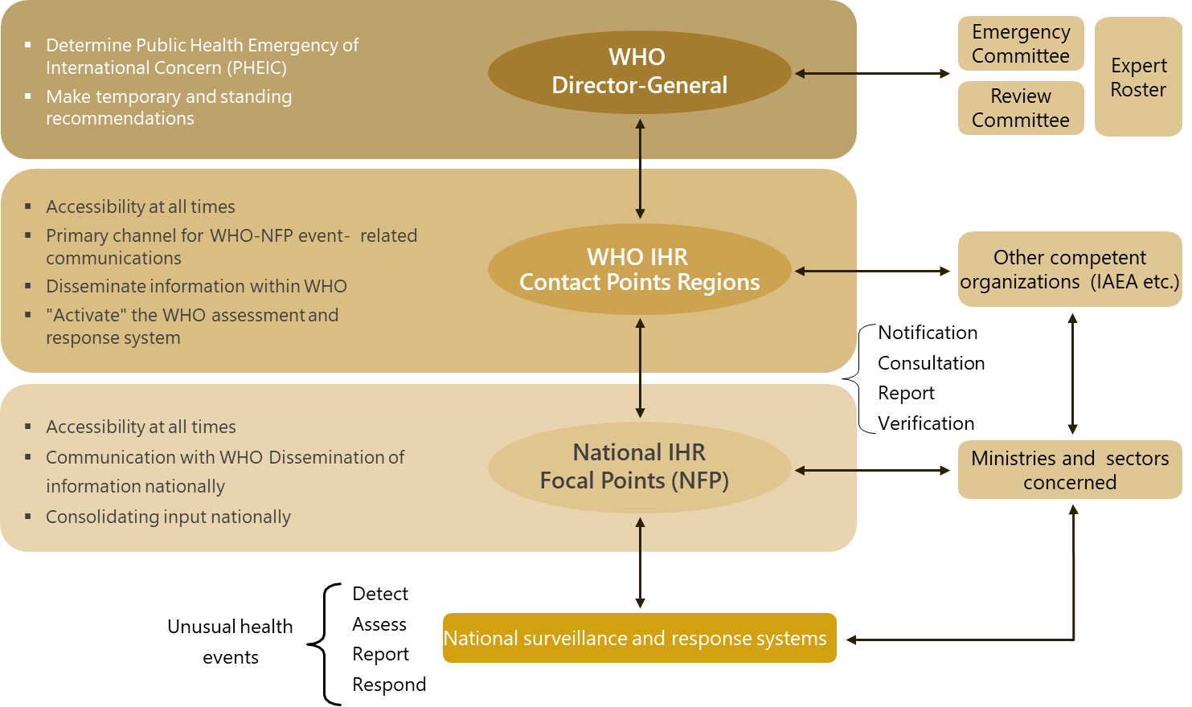
Figure 33 - IHR Framework

Recommendation for reporting capabilities of HRHIS for Skilled attendance at birth
Indicator | HRHIS for reporting on skill attendance at birth requirements
Question | Does the Human Resource for Health Information System (HRHIS) have ability to generate information for reporting on skilled attendance at birth requirements?
Recommendation | - This indicator checks the reporting abilities of HRHIS system for skilled attendance at birth.  - Skilled attendance at birth relates to Doctors, Nurses and Midwives who are specially educated and trained to handle childbirths, normal pregnancies, postnatal care and complications in women and newborns.  - High value of skilled attendance at birth indicator depicts high rate of successful deliveries and reduced maternal mortalities.  - Currently the Bayanati HRHIS system contains skilled attendants data however does not contain the patients data being attendant by those professionals. This data is present in the Wareed HIS system.
The Bayanati system should be integrated with the Wareed system in order to obtain skilled attendance at birth data for reporting to WHO.

Recommendation for HRHIS production of geocoded health facility locations
Indicator | HRHIS for producing the geocoded location of health facilities
Question | Does the Human Resource for Health Information System (HRHIS) have ability to generate geocoded information on the location of health facilities?
Recommendation | - This indicator checks the existence of geocoded location of health facilities in the HRHIS system.  - Geocoded location corresponds to the latitudinal and longitudinal location tracked down to nearest constituent town, ward or neighborhood of that particular health facility on the earth’s surface.  - Methods of geocoding typically include below areas:  - Using GPS devise for facility location.  - Satellite imagery and aerial photography platforms like Google Map, Google Earth etc.  - Using scanned and georeferenced hand-drawn maps.  - Location determination through existing maps.
The Bayanati HRHIS system should be upgraded to store the geocoded locations of the facilities associated with each staff in addition to the existing work location and organizational unit of their employees.

Recommendation for HRHIS in reporting on outputs from education and training institutions
Indicator | HRHIS for reporting on outputs from education and training institutions
Question | Does the Human Resource for Health Information System (HRHIS) have ability to generate information for reporting on outputs from education and training institutions?
Recommendation | - This indicator checks the reporting abilities of HRHIS system towards the outputs from education and training institutions.  - These outputs typically constitute below mentioned areas of accredited education and training institutions:  - Annual updated list of accredited education & training institutions and their programmes  - Applications/Admissions/Enrollments made towards these programmes  - Faculty to Student ratios  - Successful graduates data  - Dropouts data  - Currently the Bayanati HRHIS System only contains the educational qualification details of the employees and not the above-mentioned outputs.  - Benefits for containing outputs for education and training institutions in the HRHIS system:  - Aids planning towards health workforce projection and capacity  - Supports budgetary considerations for new job creation  - Promotes judicious international health workforce recruitment  - Optimizes training needs for health workforce  - Facilitates collaboration between health and education ministries  - Derives core indicators which can be submitted to WHO Secretariat annually
The Bayanati HRHIS system should be integrated with the systems used in the Ministry of Education that contain the specified outputs from education and training institutions which cumulatively provides a holistic overview of health workforce education and corresponding recruitment.

CHAPTER 16: CHALLENGES

General Challenges
The National Health Workforce Account (NHWA) was formulated as a means to meet the below mentioned global health workforce challenges faced by countries:
- Shortage of national health workforce
- Provision of high-quality education and training that supports the needs of health systems
- Equitable deployment of health workers to match populations’ needs
- Performance monitoring to ensure high-quality care nationwide
- Health workforce promotion and job retention

The NHWA programme can aid countries to address or reconsider major policy questions related to current HWF challenges and optimizing planning systems such as:
- Is the current health workforce stock sufficient, skilled and accessible for providing quality services thereby resulting in satisfaction of population needs?
- Are the identified gaps in health workforce situation addressable through optimal resource allocation, formulation of effective policies, bolstering of public and private sector partnerships and making sound investments in education and workforce production?
- What is the financial feasibility in terms of fiscal investment (salaries) and inter-sectoral negotiations for implementing policies that improve health workforce performance?
- Can the health workers entry into the labour market counterbalance the exits?
- Can financial incentives attract health workers in underserved areas and aid in job retention and balanced geographical distribution?

Challenges in NHWA Data Collection
The biggest challenge in the accurate data collection for all NHWA Modules in the UAE was that data is scattered across 7 emirates, multiple regulatory ministries and the private sector. For each NHWA module, identification of the correct stakeholder for the respective data was the key step that was taken during a NHWA Orientation workshop which included designated individuals from each Ministry in the UAE. Despite this initiative, several indicator data was not successfully obtained due to unavailability with the respective stakeholder.
The specific module-wise data collection challenges are present below

Module 1 – Active Health Work Stock
Indicator | Health worker distribution by age group  Health worker distribution by facility type
Overview | These indicators reveal the number of active health workers disaggregated by age groups and facility types namely Hospitals, Ambulatory Facilities, Residential Facilities, Retail Facilities etc.
Challenge | - We have received health worker specialization-based age demographic and facility type data from all contacted stakeholders except from DHA and DHCC.  - For DHA this data is currently unavailable.  - For DHCC data from only few facilities have been received.
Action | - We need to obtain pending data from DHA and all DHCC facilities.

Indicator | Share of foreign-trained health workers
Overview | This indicator focusses on active health workers who have obtained qualification degree outside of the UAE and practices within UAE.
Challenge | - We contacted multiple stakeholders for acquiring Manpower data with different disaggregation’s like gender, age groups, sector, training etc.  - However majority of the stakeholders responded with unavailability of data pertaining to Country of Training data of their health workers.
Action | - We shall request the concerned stakeholder entities to start tracking the Country of Training associated with highest qualification degree of each of their existing and new joiners employees.  - This should become a mandatory requirement for their employee onboarding process.

Indicator | Share of workers across health and social sectors
Overview | This indicator reveals the number of health and social sector workers in comparison to total employed population.
Challenge | - We have not received data pertaining to all employed population in UAE for the year 2018.  - This is the key denominator required for calculating this indicator.
Action | - We have requested FCSA for sharing this data and shall follow-up with them for acquiring this information.

Module 2 – Education & Training
Indicator | Ratio of admissions to available places  Exit / drop-out rate from education and training programmes  Ratio of students to qualified educators for education and training  Duration of education and training
Overview | The above-mentioned indicators are pertaining to educational parameters for healthcare based training universities and institutions in the UAE.
Challenge | - The Ministry of Education – Higher Education is the only source for acquiring this data and they have confirmed unavailability of this data.
Action | - The Ministry of Health – Higher Education collect education and training based statistical and financial data from the individual MOE licensed universities using the Centre for Higher Education Data and Statistics (CHEDS) data collection process.  - We shall request them to add these additional data requirements into the CHEDS process and aspire to obtain desired data within the end of this year.

Indicator | All indicators of this module relating to Applications, Admissions, Graduation and Drop-outs
Overview | These indicators focus around health worker education and training institutions, and information on applications, admissions, exit / drop-out and graduation.
Challenge | - We have received data like Applications, Enrollments and Graduates data specific to certain healthcare specializations from the Ministry of Education.  - However the same data is yet to be obtained from the below Free Zones namely:  - Knowledge and Human Development Authority (KHDA)  - Fujairah  - We received confirmation from RAK free zone that their institutions do not conduct healthcare based trainings hence are excluded from this data.
Action | - We shall be closely working with Ministry of Education for following-up with the other free zones in order to acquire the desired data of this module.

Module 4 – Education Finances
Indicator | All indicators of this module relating to Financing of higher education, Investments, Education Expenditure and Lifelong learning
Overview | These indicators focus around expenditures and investments incurred towards health workforce education.
Challenge | - The expenditure towards health education and training has to be independently captured from applicable MOE licensed universities.
Action | - We have contacted a focal point from the Ministry of Education – Higher Education to provide us single point of contact information for each of the universities so that we can individually obtain the desired data from them.

Module 5 – Health Labour Market Flows
Indicator | All indicators of this module relating to Labour Market Entries, Exits and Imbalances
Overview | Data in this module mainly relates to newly active workers who have just entered the UAE health labour market and existing active workers who had voluntarily/involuntarily left the market.
Challenge | - Majority of stakeholders have data on individuals who were licensed in their organization however, they do not have data confirming that those individuals were newly active into the UAE market.  - Similarly few stakeholders have provided data on worker exits however; those same workers might have joined other organizations in the same year resulting in incomplete data.
Action | - We need to identify a stakeholder that can provide cumulative end of year data on health workers that have freshly entered into the UAE health labour market as well as those workers that have become unemployed or left the market.  - We are expecting data for Unemployment and Vacancy rate from FCSA.

Module 6 – Employment Characteristics and Working Conditions
Indicator | Health workers with a part-time contract
Overview | This indicator is applicable for those active health workers that work below national standard working hours and across multiple sectors as well.
Challenge | - Majority of contacted stakeholders do not possess this data.
Action | - In the UAE, there are rare occasions where professionals opt for working across multiple sectors and need permit from MOHRE for undertaking part-time work.  - We have accordingly contacted and requested them to share the accurate numbers of Part-Time health workers in the UAE.

Indicator | Health worker status in employment
Overview | This indicator is applicable for those active health workers that are self-employed in the UAE.
Challenge | - Majority of contacted stakeholders do not possess this data.
Action | - In the UAE, obtaining self-employment requires finding sponsorship through free zones in UAE as a Contractor through an established company, or through an individual.  - There are 45 free zones within the UAE and we need to identify those wherein health care professionals work and have obtained self-employment permits.  - We shall be contacting the identified free zones for this data.

Indicator | Regulation on working hours and conditions, minimum wage, social protection, dual practice and compulsory service
Overview | These indicators describe the regulations that impact employment characteristics like work hours, leaves, salaries, multi sector employment etc.
Challenge | - In the UAE, regulations affecting employment for the public sector are governed by FAHR.  - Similarly these regulations for the private sector are governed by MOHRE.  - We have received only data for public sector regulations relating to working hours and social protection however not for all.
Action | - We are expected to receive these data for private sector from MOHRE.  - We have received few regulatory data items from FAHR however need to identify stakeholder for remaining indicators for public sector.

Indicator | Attacks on health-care system  Measures to prevent attacks on health workers
Overview | These indicators revolve around preventive measures and statistical figures on various attacks on healthcare systems. These include attacks on Healthcare Providers, Facilities, Transportation, Patients and their relatives and other areas of healthcare ecosystem.
Challenge | - We have contacted numerous stakeholders for such kind of data however we have received confirmation of unavailability of the same.
Action | - We have to identify a new stakeholder for obtaining such kind of healthcare attacks related data.  - We have been advised to check police records across emirates for a potential figures relating to these indicators.

Module 7 – Health Workforce Expenditure
Indicator | Total expenditure on health workforce  Total expenditure on compensation of health workers  Entry-level wages and salaries
Overview | These indicators correspond to the total expenditure inclusive of compensations, salaries, social contributions and training incurred on health workforce.
Challenge | - Health workforce expenditure data is not complete as it is not received from all relevant stakeholders.  - We have received health worker expenditure data only from MOHAP and partial data from MOPA.  - Many contacted stakeholders from public sector like DOH and DHA have confirmed unavailability of this data.  - From the private sector, we have received data from small percentage of DHCC based healthcare facilities.
Action | - We shall follow-up with DHCC in order to obtain data inclusive of all of their facilities.  - We shall also reconfirm availability of financial data from previously contacted stakeholders.

Module 10 – Health Workforce Information Systems
Indicator | HRHIS for WHO Global Code of Practice reporting
Overview | This indicator checks the ability of HRHIS to generate information to report on implementation of the WHO Global Code of Practice on the International Recruitment of Health Personnel.
Challenge | - We have not received any information regarding this indicator from contacted stakeholders.
Action | - We need to identify a stakeholder wherein HRHIS system is utilized for sending reports to WHO in terms of international recruitment of migrant workers in the UAE.

Glossary

Source: WHO - (National Health Workforce Account - A Handbook)
Term | Definition
Accreditation | A process by which an officially approved body, on the basis of assessment of learning outcomes and/ or competences according to different purposes and methods, awards qualifications (certificates, diplomas or titles), or grants equivalences, credit units or exemptions, or issues documents such as portfolios of competences. The term accreditation applies to the evaluation of the quality of an institution or a programme as a whole.  - Accreditation mechanisms: Mechanisms and procedures for implementation of an accreditation process.  - Accreditation standards: Standards that guide health workforce education programme development and evaluation, facilitate diagnosis of strengths and weaknesses relating to the education programme, and stimulate quality improvement.  - Accreditation systems: A system that is: based on standards; supported by a legislative or legal instrument; independent; transparent; non-profit-making; accountable; representative of, but independent from all major stakeholders; and efficiently administered.
Active health worker | One who provides services to patients and communities (practising health worker) or whose medical education is a prerequisite for the execution of the job (e.g. education, research, public administration) even if the health worker is not directly providing services (professionally active health worker). If data are not available for practising or professionally active health workers, data with the closest definition can be used, such as “health worker licensed to practice”.
Active health workforce stock | This comprises of the size, composition and distribution of health workforce within a country.
Advanced practice nurse | A registered or other professional nurse who has acquired the expert knowledge base, complex decision-making skills and clinical competencies for expanded practice, the characteristics of which are shaped by the context and/or country in which the nurse has credentials to practise. A master’s degree is recommended for entry level.
Ambulatory care | Personal health-care services delivered by individuals and organizations on an outpatient basis.
Compensation of employees | The total remuneration, in cash or in kind, paid by an enterprise to an employee in return for work performed by the latter during the accounting period. It includes wages, salaries, and all forms of social benefits, payments for overtime or night work, bonuses, allowances, as well as the value of in-kind payments such as the provision of uniforms for medical staff.
Continuing professional development | Training that is beyond clinical update and includes wide-ranging competences like research and scientific writing; multidisciplinary context of patient care; professionalism and ethical practice; communication, leadership, management and behavioral skills; team building; information technology; auditing; and appropriate attitudinal change to ensure improved patient service, research outcomes, and attainment of the highest degree of satisfaction by stakeholders. The form of continuing professional development (CPD) may include: courses and lectures; training days; peer review; clinical audit; reading journals; attending conferences; e-learning activity. CPD may be included in national standards of conduct, performance and ethics that govern health workers.  Continuing professional development (mandatory)  National systems for continuing CPD may be voluntary or mandatory. Mandatory systems may include the requirement for both verifiable and general and non-verifiable CPD. Verifiable CPD is activity that meets an agreed definition of CPD and for which there is documentary evidence that the health worker has undertaken CPD with concise educational aims and objectives; clear anticipated outcomes; and quality controls.
Domestic trained health worker | A health worker who obtained his/her first qualification in the country where s/he is entitled to practice.
Enrolment | Number of new entrants in the first year of an education programme.
Family medicine practitioner | Part of generalist medical practitioners classified in ISCO-08 code 2212. Also referred to as general practitioners and in some countries considered as a specialization, they provide person-centred continuous and comprehensive medical care to individuals and families in their communities. This group does not include resident medical officers, medical interns or other generalist medical practitioners not in general practice activities.
Field epidemiology training programme (FETP) | A health training programme with field investigations to develop experience and specialist skills based on practical application of epidemiological methods. FETP training levels are defined as:  - Basic level: for local health staff, comprising limited classroom hours interspersed throughout 3–5 month on-the-job field assignments to build capacity to conduct timely outbreak detection, public health response, and public health surveillance.  - Intermediate level: for district/regional epidemiologists, comprising limited classroom hours interspersed throughout 6–9 month on-the-job mentored field assignments to build capacity to conduct outbreak investigations, planned epidemiologic studies, and public health surveillance analyses and evaluations.  - Advanced level: using a national focus for advanced epidemiologists, it consists of limited classroom hours interspersed throughout 24-month mentored field assignments to build capacity in outbreak investigations, planned epidemiologic studies, public health surveillance analyses and evaluations, scientific communication and evidence-based decision-making for development of effective public health programming.
Foreign-born health worker | A health worker born in a country other than the one in which s/he performs health-related activities.
Foreign-trained health worker | A domestic health worker who obtained his/her qualification (degree) in another country and is entitled to practise in the receiving country.
Graduate | An individual who has successfully completed an education programme, according to the International Standard Classification of Education 2011.
Health information system | The health information system provides the underpinnings for decision-making and has four key functions:  (i) data generation, (ii) compilation, (iii) analysis and synthesis, and (iv) communication and use. The health information system collects data from health and other relevant sectors, analyses the data, ensures their overall quality, relevance and timeliness, and converts the data into information for health-related decision-making.
Health workforce education and training institution | An established institution that provides education as its main purpose, such as a school, college, university or training centre. Such institutions are normally accredited or sanctioned by the relevant national education authorities or equivalent to award qualifications. Educational institutions may also be operated by private organizations, such as religious bodies, special interest groups or private educational and training enterprises, both for profit and non-profit.
Health workforce education and training place | A place may be offered, by a health workforce education and training institution, to an applicant who meets the published minimum admission requirements for a particular programme. The number of places denotes the capacity of an education and training institution and its programmes.
Health workforce education and training programme | A “coherent set or sequence of educational activities or communication designed and organized to achieve pre-determined learning objectives or accomplish a specific set of educational tasks over a sustained period” with the objective to improve health knowledge, skills and competencies applied to health and enable the training of new health workers. Health workforce education and training programmes will often have a numerus clauses that restricts the number of places for a given programme.
Health workforce planning | Strategies that address the adequacy of the supply and distribution of the health workforce according to policy objectives and the consequential demand for health labour.
Health Worker Density | Health Worker Density includes the total number of health workers across healthcare specializations such as Medical Doctors, Nurses, Dentists, Pharmacists, Technicians etc in a given country in terms of 10,000 population.
Higher education | Includes “all types of studies, training or training for research at the post-secondary level, provided by universities or other educational establishments that are approved as institutions of higher education by the competent State authorities”.
Human resources for health | All persons engaged in actions whose primary intent is to enhance health (WHO definition). Three categories of workers relevant for health workforce analysis can be distinguished:  - Those with health vocational education and training working in the health services industry  - Those with training in a non-health field (or with no formal training) working in the health services industry, and  - Those with health training who are either working in a non-healthcare related industry, or who are currently unemployed or not active in the labour market
In-service training | Training received while one is employed in the health sector.
International Health Regulations (2005) | An international legal instrument that is binding on 196 countries across the globe, including all Member States of WHO. Its aim is to help the international community prevent and respond to acute public health risks that have the potential to cross borders and threaten people worldwide.
Inter-professional education | When two or more health professionals learn about, from and with each other to enable effective collaboration and improve health outcomes. “Professional” is an all-encompassing term that includes individuals with the knowledge and/or skills to contribute to the physical, mental and social well-being of a community.
Licensure | The granting of a permit (licence) or mandatory certification to practise in the appropriate field of health, issued by a legitimate regulatory body within the profession.
Lifelong learning | All general education, vocational education and training, non-formal education and informal learning undertaken throughout life, at all levels and all settings, resulting in an improvement in knowledge, skills and competences, which may include professional ethics.
Medical doctor or physician: generalist | Generalist medical practitioners (ISCO 2008 code 2211) including family and primary care doctors, who diagnose, treat and prevent illness, disease, injury, and other physical and mental impairments and maintain general health in humans through application of the principles and procedures of modern medicine. They plan, supervise and evaluate the implementation of care and treatment plans by other health-care providers. They do not limit their practice to certain disease categories or methods of treatment, and may assume responsibility for the provision of continuing and comprehensive medical care to individuals, families and communities.
Medical doctor: specialist | Specialist medical doctors (ISCO 2008 code 2212) diagnose, treat and prevent illness, disease, injury and other physical and mental impairments using specialized testing, diagnostic, medical, surgical, physical and psychiatric techniques, through application of the principles and procedures of modern medicine. They plan, supervise and evaluate the implementation of care and treatment plans by other health-care providers. They specialize in certain disease categories, types of patient or methods of treatment, and may conduct medical education and research activities in their chosen areas of specialization.
Newly active health worker | A health worker who starts activity in the given year in the given profession.
Public expenditure | Expenditure from public funds. Public funds are state, regional and local government bodies and social security schemes. Public capital formation includes publicly-financed investment in facilities plus capital transfers to the private sector for construction and equipment.
Relicensure | Recertifying a health worker as having attained the standards required to practise a particular occupation.
Remuneration | Average gross annual income, earned by employees or those self-employed, i.e. income per year and per person, before any deductions are made for social security contributions or income tax. A person may have more than one qualifying job in any given reference period.
Skill mix | A broad term that refers to the combination or grouping of different categories of staff in the workforce, or the demarcation of their roles and activities. It is also used to describe the mix of posts, grades or occupations in an organization (as in ‘‘grade mix’’).  Buchan and O’May offer the following definition in the context of health-care provision:  - a combination of skills available at a specific time  - a mix of posts in a given facility  - a mix of employees in a post  - a combination of activities that are comprised in each role  - differences across occupational groups such as nurses and physicians or between various sectors of the health system, or  - a mix within an occupational group such as the different types of nursing providers with different levels of training and different wage rates.
Social accountability | The obligation of an authorized body to direct its education, research, and service activities towards addressing the priority health concerns of the community, region, and/or nation it has a mandate to serve.
Social determinants of health | The conditions in which people are born, grow, work, live, and age, and the wider set of forces and systems shaping the conditions of daily life. These forces and systems include economic policies and systems, development agendas, social norms, social policies and political systems.
Specialist surgical workforce | Includes licensed and qualified physician surgeons, anaesthesiologists and obstetricians.
Subnational level | To be defined according to the specific conditions, governing structures, and constitutional provisions existing in a given country. Disaggregation based on administrative boundaries down to the first or second subnational level is recommended (depending on the structure of administrative boundaries and the size of subnational territories), without overlaps between the administrative units. Examples for subnational administrative units are states, regions, provinces, counties, and districts.
Total expenditure on the health workforce | The sum of expenditures on compensation of employees (FP.1): wages and salaries (FP.1.1); social contributions (FP.1.2); all other costs related to employees (FP.1.3); self-employed professional remuneration (FP.2). Expenditure on mandatory continuing professional development should be included within social contributions.
Total public expenditure on health workforce education | Current and capital expenditure expressed as a percentage of gross national income (or gross national product) in a given financial year. This indicator shows the proportion of income spent by government authorities on health workforce education over a given financial year. This can also be calculated based on gross domestic product.
Transformative (health workforce) education | The sustainable expansion and reform of health workforce education and training to increase the quantity, quality and relevance of health workers, and in so doing strengthen national health systems and improve population health outcomes.
Unemployment | All persons of working age who are qualified for a job, are not in employment, have carried out activities to seek employment during a specified recent period, and are currently available to take up employment given a job opportunity.
Vacancy rate | The proportion of total posts that are vacant according to the definition of the job vacancy, expressed as a percentage of total positions, both filled and unfilled.




